

Professional, Creditable, Successful

DGUS_SDK User Guide_V5.1

Beijing DWIN Technology Co., Ltd.

##### Professional, Creditable, Successful DGUS_SDK User Guide V5.1

Contents

1. DGUS_SDK Instruction 4
   1. Operation of DGUS_SDK 4
   2. Main Interface of DGUS_SDK_V5.1 5
2. Basic Steps for DGUS_SDK Operation 7
   1. Create a new project 7
      1. Start a new project 7
      2. Select corresponding resolution and save the path 8
      3. Add images 8
      4. Create a CONFIG.TXT file for setting system parameters 9
   2. Configure touch functions 11
   3. Configure variable display 12
   4. Create configuration files 13
   5. Download 14
3. Main Functions of DGUS_SDK 15
   1. Touch Config 16
      1. Popup Window 16
      2. Variable Data Input 17
      3. Incremental Adjustment 18
      4. Slider Adjustment 19
      5. RTC 20
      6. Basic Touch Control 21
      7. Return Key Code 22
      8. ASCII Input 23
      9. Firmware Parameter Settings 24
      10. Status sync-returned 26
   2. Variable Config 28
      1. Variable Icon 28
      2. Animation Icon 29
      3. Slider 30
      4. WordArt 31
      5. Image Animation 32
      6. Icon Rotation 33
      7. Data Variable 34
      8. Text Display 35
      9. Digital RTC Display 36
      10. Analog Clock Display 37
      11. Dynamic Trend Curve 38
      12. Table Display 39
      13. Basic Graphic Display 40
      14. Special Industrial Application 42
      15. Bit Variable Icon 43
      16. Timer Variable 45
      17. RollText 46
4. Commands 47
   1. Data Frame 47

Professional, Creditable, Successful DGUS_SDK User Guide V5.1

* 1. Command Set 47
  2. Register 47
  3. VP & SP 49
     1. VP (Variable Pointer) 49
     2. SP (Stack Pointer) 51
  4. Examples 53
     1. Access Register of DGUS 54
        1. Write Data into Register 54
        2. Read Data from Register 54
        3. Response from the DGUS module 54
     2. Access Variable SRAM 55
        1. Write Data into variable SRAM 55
        2. Read Data from variable SRAM 55
        3. Response from the DGUS module 55
     3. Dynamic Trend Curve Display 55
     4. Basic Graphic Display 56

Professional, Creditable, Successful DGUS_SDK User Guide V5.1

# DGUS_SDK Instruction

## Operation of DGUS_SDK

1. DGUS (DWIN Graphical Utility Software) is an intelligent GUI design software for DWIN DGUS LCM with K600+ kernel. As be helpful to interface of display design faster than ever, diversified display effects can be achieved easily and rapidly with much less programming. The variables in use are defined by software DGUS_SDK v5.1 that is accessed by controller via address. All parameters and images can be downloaded via SD card which stores related .bin files to make your design into real application.
2. Install DGUS_SDK_V5.1:

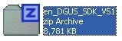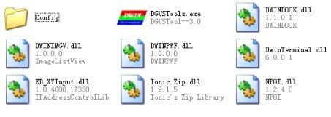Unzip DGUS_SDK_V5.1.zip, and click DGUS ToolV5.1.exe to run it. (.net Framework 2.0 is required to run the software).

1. Variable Definition
   * **VP (Variable Pointer):** The addresses of variables in variable SRAM (56KB). Users can set buttons with defined VP, to change the value in this address and display contents corresponding with the value in VP address.
   * **SP (Stack Pointer):** the address of definitions, starting address of description data of variables. Change the value in particular address to modify variable properties. Take <WordArt> function as example.

|  |  |  |  |  |
| --- | --- | --- | --- | --- |
| **Add.** | | **Definition** | **Data**  **Length** | **Description** |
| 0x00 |  | 0x5A03 | 2 |  |
| 0x02 |  | *SP | 2 | Stack pointer, default setting is 0xFFFF. |
| 0x04 |  | 0x0007 | 2 | The whole process length (in terms of words). |
| 0x06 | 0x00 | *VP | 2 | Variable pointer. |
| 0x08 | 0x01 | X,Y | 4 | Top-left coordinate of text, left aligned. |
| 0x0C | 0x03 | Icon0 | 2 | Icon ID corresponding to 0, the sequence is “0123456789-.”. |
| 0x0E | 0x04:H | Icon_Lib | 1 | Address of icon file. |
| 0x0F | 0x04:L | Icon_Mode | 1 | ICON display mode.  0x00: transparent, others: opaque. |
| 0x10 | 0x05:H | Int_Num | 1 | Length of integer digits. |
| 0x11 | 0x05:L | Dec_Num | 1 | Length of decimal digits. |
| 0x12 | 0x06:H | VP_Data_Mode | 1 | 0x00: integer (2 bytes), 0x01: long integer (4 bytes). |

*E.g.: If SP valued as 0x5000 for WordArt variable, VP parameter will be saved in the ADDRESS of 0x5000. Variable position parameters will be saved in 0x5001-0x5002*

1. If you need to handle with icons, please drop icon files into Icon Generator to make icon file running in DGUS correctly.
2. How to select area for buttons & variables.
3. Input coordinates directly.

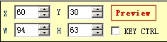 or 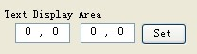

1. 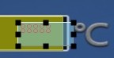Drag the button/variable with mouse.
2. Define SP address for variables.

##### Professional, Creditable, Successful DGUS_SDK User Guide V5.1

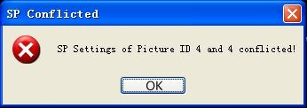SP defines the description of variable settings; to reduce overlap of SP address is necessary. There is overlap judging embedded, Configuration files won’t be created with failure message when it comes an overlap of SP address.

1. Import existing DGUS config. files into new project.
2. Create a new project.
3. Add pictures.
4. Import config files.
5. Copy icon files into <DWIN_SET> folder.

***Note: Frame header is self-defined by users. In this document, A5 5A is taken as frame header for instance.***

## Main Interface of DGUS_SDK_V5.1

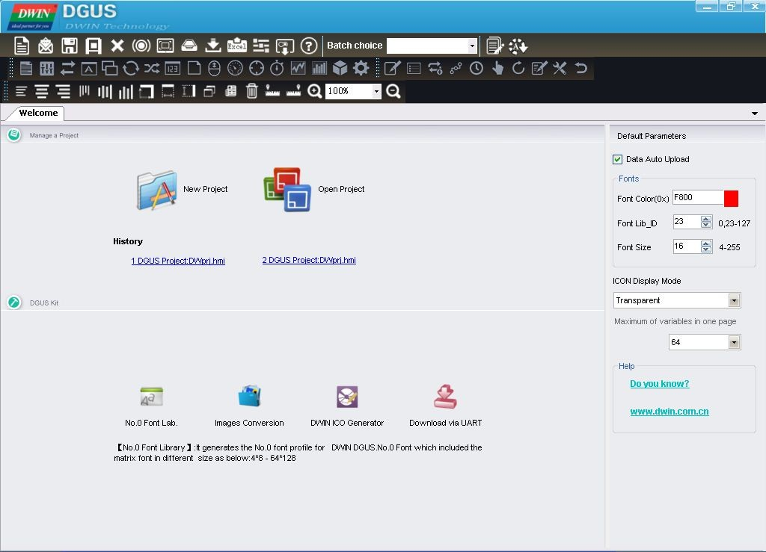

1. Click <New Project> to activate the window below:

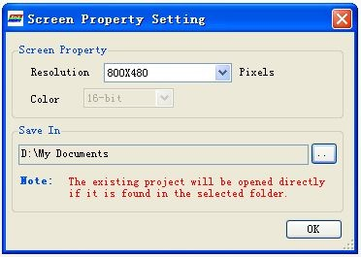

1. Select resolution and path for your project.

##### Professional, Creditable, Successful DGUS_SDK User Guide V5.1 Screen Property Set.

E.g. for:

DM**T**80480T070_06WT.

Color **T**: 16bit.

Resolution 80480: 800x480.

## Navigation Bar:

|  |  |
| --- | --- |
| **New** | Create a new project. |
| **Open** | Open an existing project (.hmi file). |
| **Save** | Save the current project. |
| **Save As** | Save the current project in a new folder. |
| **Close** | Close the current project. |
| **Variables Preview** | Preview buttons & variables |
| **Resolution** | Modify resolution of project. |
| **Generating**  **Configuration file** | Modify system configuration and save the settings in config.txt. Refer to illustration  below. |
| **Import Config.** | Import existing config. files to the current project. |
| **Export Variables** | Generate <TouchConfig.xls> and <DisplayConfig.xls> for quick view of buttons &  variables. |
| **System Properties** | Modify system properties and save the settings in config.txt. Refer to illustration  below |
| **DGUS Configuration File**  **Download** | Download <13Touch_Control_Config.bin>, <14Variable_Config.bin>, and the image;  debug commands via serial port. |
| **Help** | Help documents. |
| **Align Left** | Align the selected buttons and variables to left. |
| **Align right** | Align the selected buttons and variables to right. |
| **Align Top** | Align the selected buttons and variables to top. |
| **Align bottom** | Align the selected buttons and variables to bottom. |
| **Auto Width** | Adjust the selected buttons & variables at same width. |
| **Auto Height** | Adjust the selected buttons & variables at same height. |
| **Vertical centered** | Adjust the selected buttons & variables at the vertical center. |
| **Horizontal centered** | Adjust the selected buttons & variables at the horizontal center. |
| **Copy** | (Ctrl + C)**:** copy |
| **Paste** | (Ctrl + V)**:** paste |
| **Delete** | (delete)**:** delete |
| **Front** | Place the button or variable at front layer. |
| **Back** | Place the button or variable at backward layer. |
| **SP Address Setting** | Set SP for variables. |
| **Variables Preview** | Preview buttons & variables |
| **Show Text** | show the names of buttons & variables or not. |

Reference：*Inputted data will be sent via serial port only when both <TPSAUTO> in System Config. Window and <Data Auto Upload> settings in buttons properties are ticked.*

##### Professional, Creditable, Successful DGUS_SDK User Guide V5.1

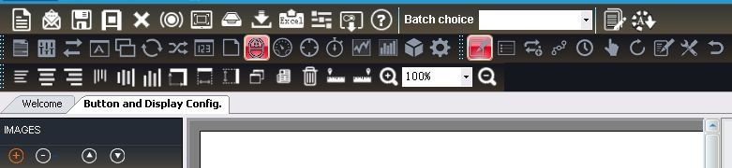

*T**o**ol Bar:*

Switching between "Touch Config" & "Variable Config" & Edit Tools using Navigation bar, or shortcut key F2, F3,F4.

# Basic Steps for DGUS_SDK Operation

## Create a new project

## Start a new project

Open the DGUS_SDK_V5.1 > Click “New Project” button to start a new project.

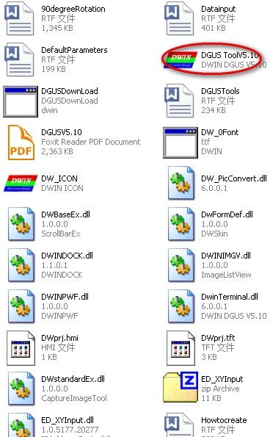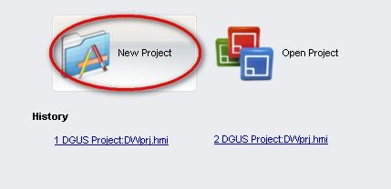

Professional, Creditable, Successful DGUS_SDK User Guide V5.1

## Select corresponding resolution and save the path

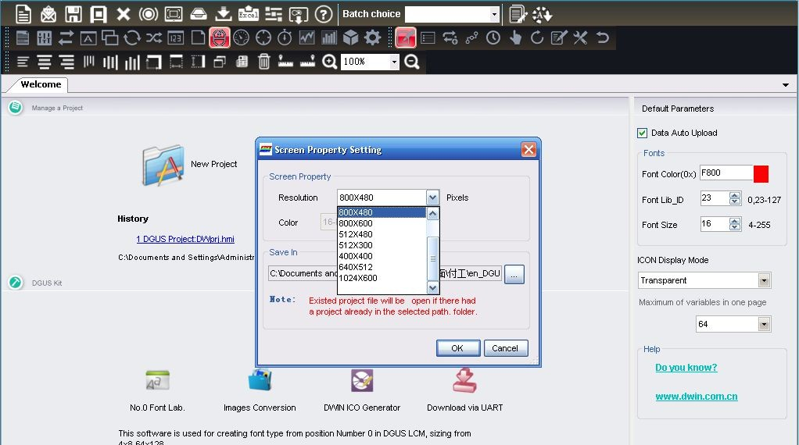

## Add images

Images indicating here are what to be displayed as background with “.bmp” format required. Image naming rules: ID + Name. bmp (name as optional)

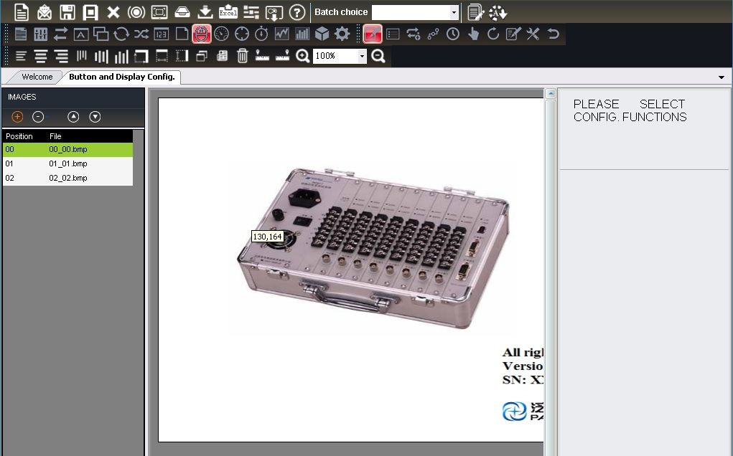For example, “0_Data Input.bmp” or “0.bmp”

Professional, Creditable, Successful DGUS_SDK User Guide V5.1

## Create a CONFIG.TXT file for setting system parameters

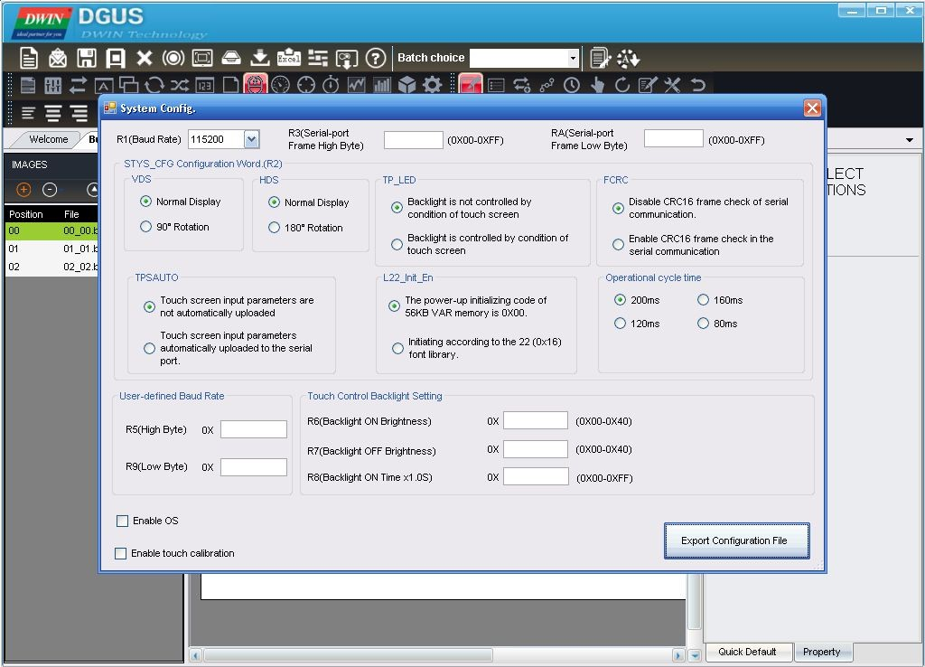Step into setting such system as baud rate, backlight, as well as cycle time etc.

Export Configuration File – “CONFIG. txt”

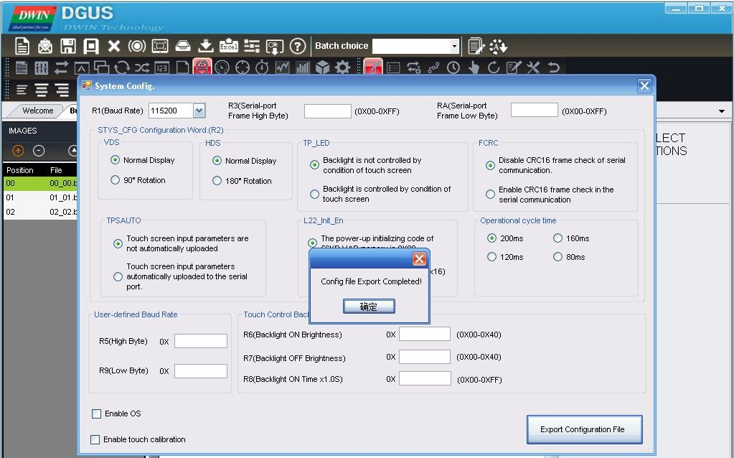

##### Professional, Creditable, Successful DGUS_SDK User Guide V5.1

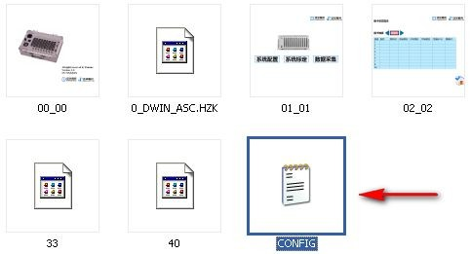

For the value and functions of each parameters, please refer to the chapter 1.2 of the DGUS Dev. Guide_V5.1—CONFIG. TXT

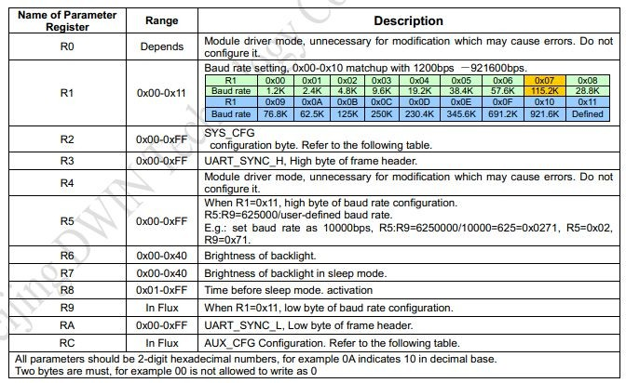

##### Professional, Creditable, Successful DGUS_SDK User Guide V5.1

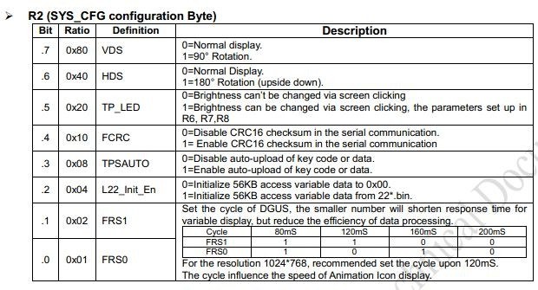

*If* *the frame header is set as R3=5A RA=A5, please use the software “Serial debugging assistant sscom32 " sending command below for verifying all images works fine.*

*5A A5 04 80 03*

*00 01( 00 01 signify images switching to No1.)*

*Later, check if images No1 switched successfully. (format must be .bmp naming started from”00”).*

*There are config.txt failed or com port out of work in the event of images switch failure. Please affirm parameter for config.txt again including frame header, baud rate etc.*

## Configure touch functions

Select the “Touch Config” from pull-down menu-------> Add touch function, as “Data Input” > Drag a square on your button

as follow yellow area > Set the properties, such as button effect, key value, etc.

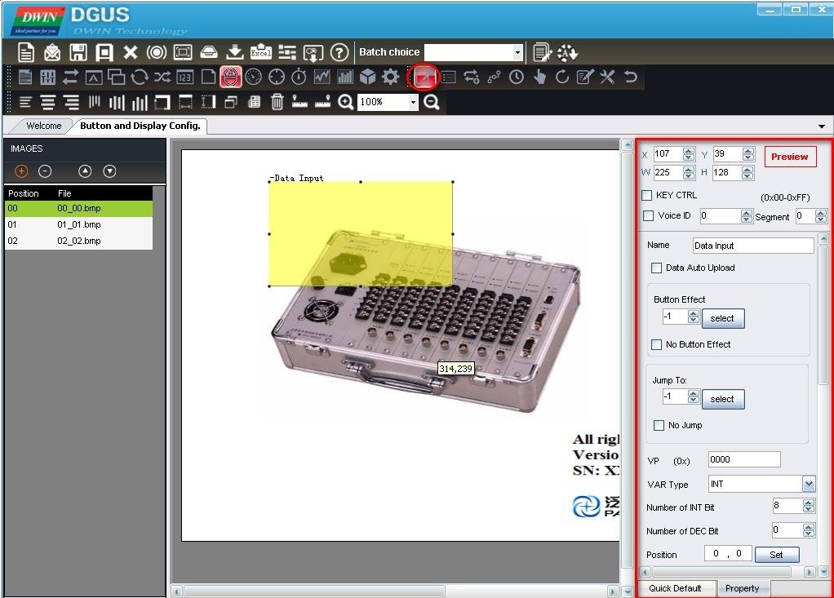

Professional, Creditable, Successful DGUS_SDK User Guide V5.1

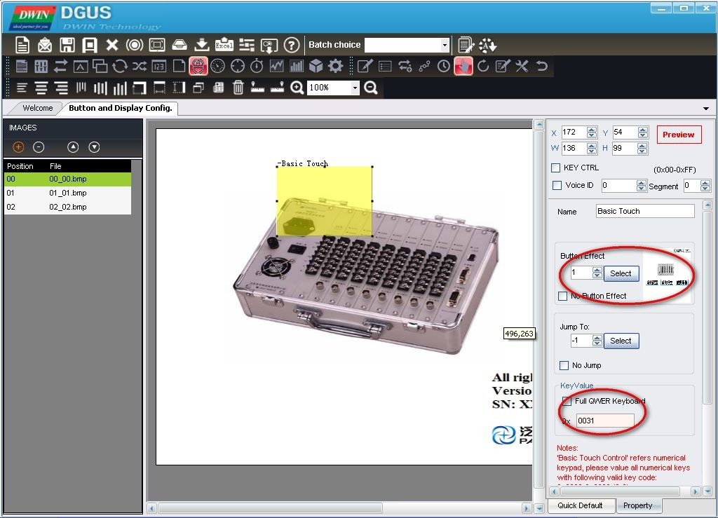

## Configure variable display

Select the “Variable Config” from pull-down menu -------> add the display function, as “Data Variable” >Drag a blue square

on area, the variable will be displayed based on the upper-right coordinates > Set the properties of variable as font color, font

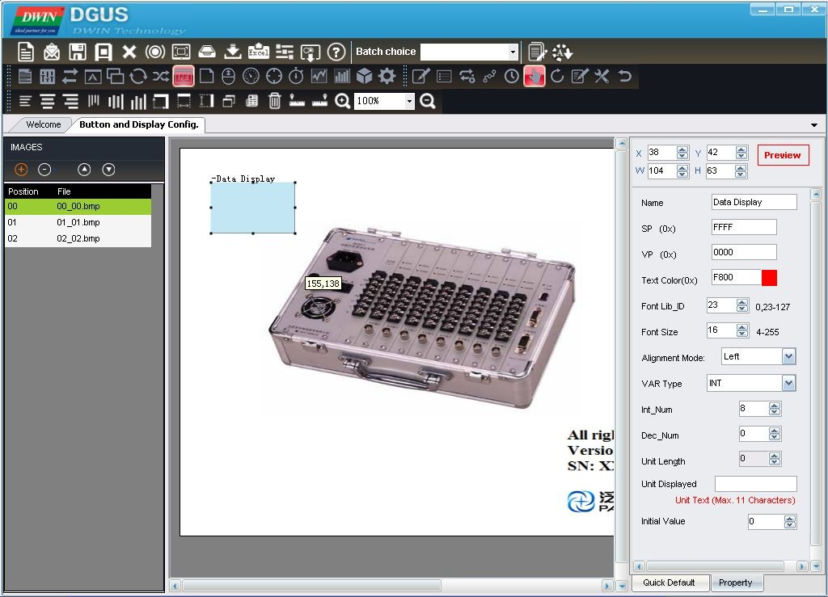ID.

Professional, Creditable, Successful DGUS_SDK User Guide V5.1

## Create configuration files

Click the “Generating Configuration File” button, it will create a touch control configuration file and a variable configuration file. Their default file names are “13Touch_Control_Config.bin” and” 14Variable_Config.bin “which cannot be renamed, or the project can’t be opened properly.

Please note that 13&14 bin file must be dropped in corresponding DWIN_SET folder if file downloaded via UART, otherwise pop-up red warning will show up warning correct file are not found.

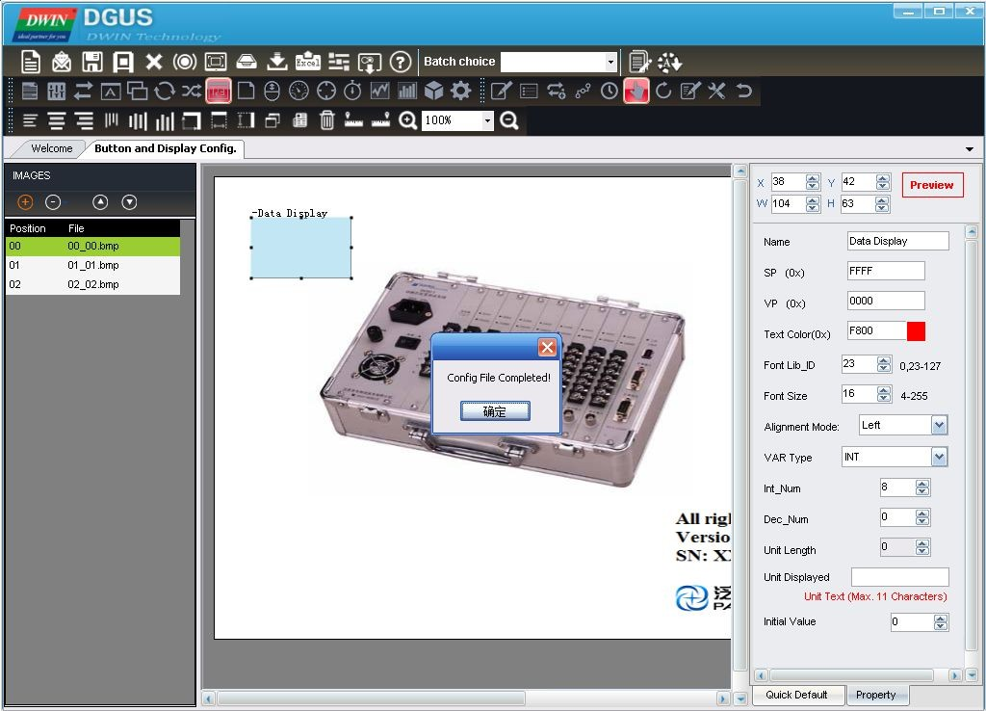

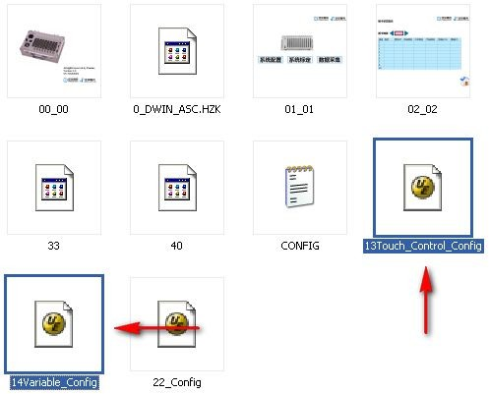

Professional, Creditable, Successful DGUS_SDK User Guide V5.1

## Download

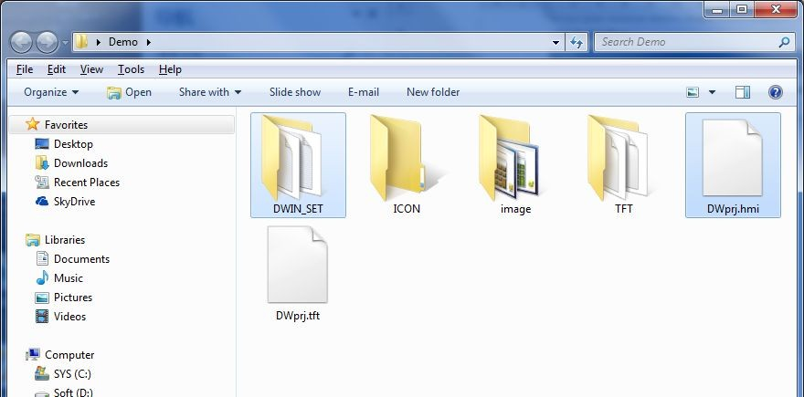When you completed above steps, it will create a DWIN_SET folder and a project named DWprj.hmi in the path you selected before.

The DWIN_SET folder includes as follow:

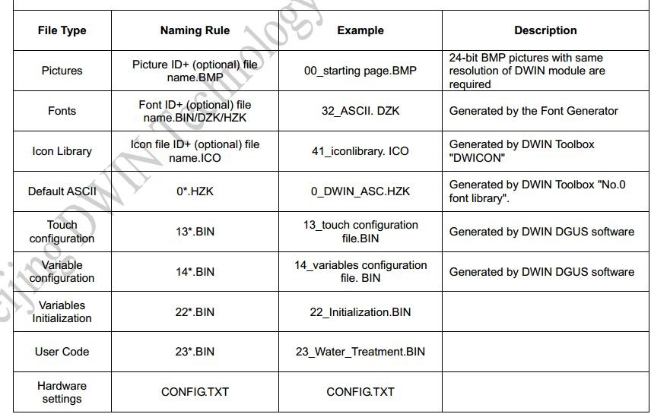

##### Professional, Creditable, Successful DGUS_SDK User Guide V5.1

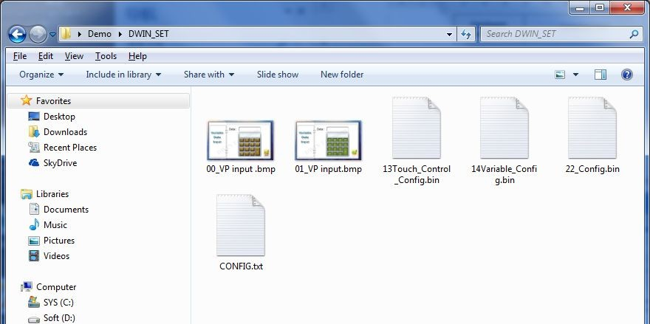

Copy the DWIN_SET folder into the SD card root directory ------> Powered on DGUS LCM > Insert SD card into the slot of

LCM, the configuration files will be downloaded automatically.

Note: During downloading, don’t turn off the LCM, the screen will blink to blue then back to the first image after completion

# Main Functions of DGUS_SDK

**Touch Config :** users can use DGUS_SDK software to add buttons on screen, including Popup Window, Variable Data Input, Incremental Adjustment, Slider Adjustment, RTC Setting, Touch Control, Return Key Code, and ASCII Input. Buttons are

shown as yellow rectangles in DGUS_SDK_V51. Users can also add press effect for buttons.

**Variable Config :** users can use DGUS_SDK to add variables on screen, including Variable Icon, Animation Icon, Slider, WordArt, Image Animation, Icon Rotation, Data Variable, Text Display, RTC Display, Analog Clock Display, Dynamic Trend Curve Display, Table Display, and Basic Graphic Display, Bit Icon, Timer Variable. Variables are shown as light-blue rectangles in DGUS_SDK_V51.

**Parameter settings:** users can use <System Properties> to adjust parameter settings of DGUS module. Parameter with “0x” in front should be filled with hex numbers.

Professional, Creditable, Successful DGUS_SDK User Guide V5.1

# Touch Config.

## Popup Window

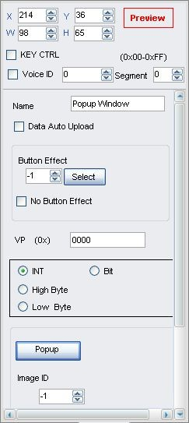

*Illustration of button <Popup Window>:*

**Selected Area:** selected button area.

**Preview:** preview button effect.

**Name:** name this button for viewing it in .xls (Excel) file.

**Data Auto Upload:** after pressing the button, key code auto sent to serial port.

**Button Effect:** set picture ID for touching effect, -1: null.

**VP:** variable pointer.

#### VAR Type:

INT: write key code in VP address (word).

High Byte: write low byte of key code in high byte of VP. Low Byte: write low byte of key code in low byte of VP.

Bit: write data from last bit of key code into designated bit of VP address. (0x10 corresponds to VP.0, 0x1F corresponds to VP.F).

**Popup Window:** set window picture ID and window area.

**Image ID:** image ID of window picture.

**Cut Area:** cut area in image ID.

**Paste Position:** position of window on current screen.

##### Note: Only <Touch Control> buttons will work on popup window.

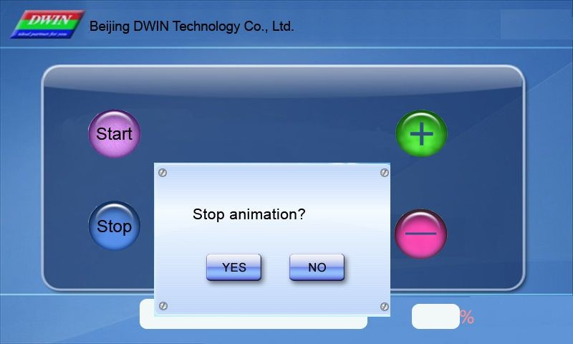

*Click <Stop> button - Window pops up - Select YES/NO.*

Professional, Creditable, Successful DGUS_SDK User Guide V5.1

## Variable Data Input

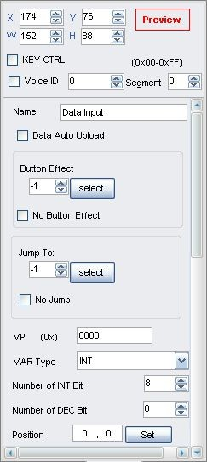port.

**Selected Area:** selected button area.

**Preview:** preview button effect.

**Name:** name this button for viewing it in .xls file.

**Data Auto Upload:** after pressing the button, key code auto sent to serial

**Button Effect:** set picture ID for touching effect, -1: null.

**Jump To:** switch to a new picture after pressing.

**VP:** variable pointer.

#### VAR Type:

INT: integer.

LONGINT: long integer.

High byte: high byte in VP address. Low byte: low byte in VP address.

**Number of INT Bit:** length of integer digits.

**Number of DEC Bit:** length of decimal digits.

**Position:** data position when typing. **Font Color:** data color when typing. **Font ID:** address of ASCII font file. **Font Size:** horizontal pixel numbers. **Cursor Color:** white/black cursor.

**Display Mode:** masked by (*)/direct display.

#### Define Keyboard:

Set the keyboard picture ID and the keyboard area.

**Image ID:** image ID of the keyboard area.

**Cut Area:** cut area in image ID.

**Paste Position:** position of the keyboard on current screen.

#### Enable VAR Input Limitation:

Set limits for inputting numbers.

**Notes:** Only <Touch Control> buttons will work on keyboard: 0x00F1 (Confirm), 0-9 corresponds to 0x0030 - 0x0039, 0x00F0 (Cancel), 0x00F2 (Backspace), 0x002D (+/-), 0x002E (.).

Ignore decimal point while setting range restriction for return value. E.g.: the setting is 3 integer bits and 2 decimal bits, and then the top limit is 10000, rather than 100.

Inputted data can be displayed by <Data Variable>, <WordArt> etc.

##### Professional, Creditable, Successful DGUS_SDK User Guide V5.1

*Il**lustration of button <Variable Data Input>:*

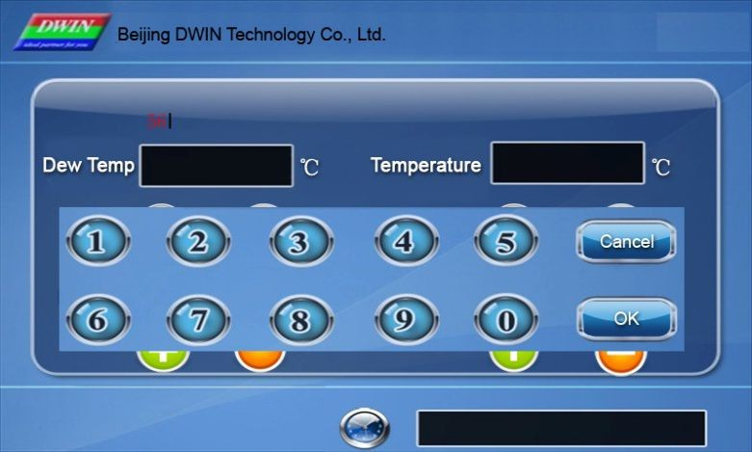

*Click text – Keyboard pops up – Type data – OK. Click <Cancel> to interrupt input.*

## Incremental Adjustment

**Selected Area:** selected button area.

**Preview:** preview button effect.

**Name:** name this button for viewing it in .xls file.

**Data Auto Upload:** after pressing the button, key code auto sent to serial port.

**Button Effect:** set picture ID for touching effect, -1: null.

**VP:** variable pointer.

#### VAR Type:

0x00: integer.

0x01: high byte in VP address. 0x02: low byte in VP address.

0x10 – 0x1F: adjust value in designated bit of VP address. (0x10 corresponds to VP.0, 0x1F corresponds to VP.F) Step Size must be 0 or 1.

**Adjustment Method:** ++/--.

**Over-limit Operation:** stop/ cycle.

**Step Size:** set step size for +/- buttons. **Min. Value:** minimum value for adjustment. **Max. Value:** maximum value for adjustment.

Adjusted data can be displayed by <Data variable>, <Icon variable> and

<WordArt> etc.

##### Professional, Creditable, Successful DGUS_SDK User Guide V5.1

*Il**lustration of button <Incremental Adjustment>:*

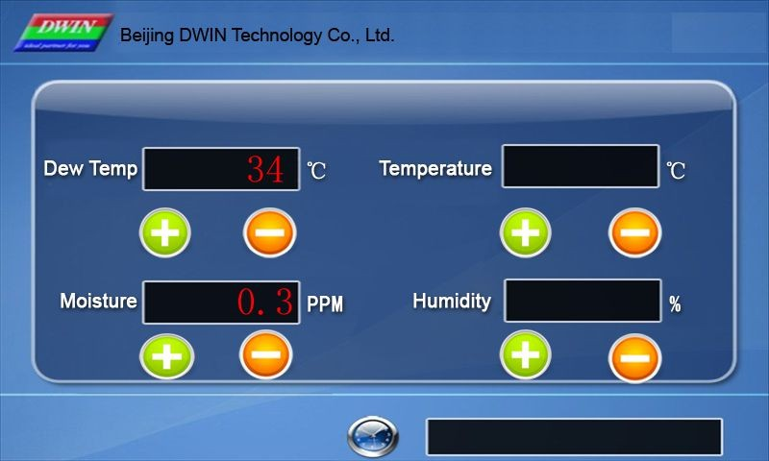

*Click <+> or <-> to adjust corresponding value. Hold the button to adjust continually.*

## Slider Adjustment

port.

**Selected Area:** selected button area.

**Preview:** preview button effect.

**Name:** name this button for viewing it in .xls file.

**Data Auto Upload:** after pressing the button, key code auto sent to serial

**VP:** variable pointer.

#### Value Return Type:

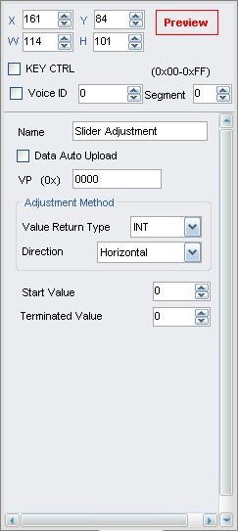0x00: integer.

0x01: high byte in VP address. 0x02: low byte in VP address. **Direction:** horizontal/vertical.

#### Start Return Value:

The value corresponding to left/top side of slider.

#### Terminated Value:

The value corresponding to right/bottom side of slider.

This function is only for making touching area for slider. To display it, please use <Slider display> function.

Adjusted data can be displayed by <Data variable>, <Variable icon> etc.

##### Professional, Creditable, Successful DGUS_SDK User Guide V5.1

*Il**lustration of button <Slider Adjustment>:*

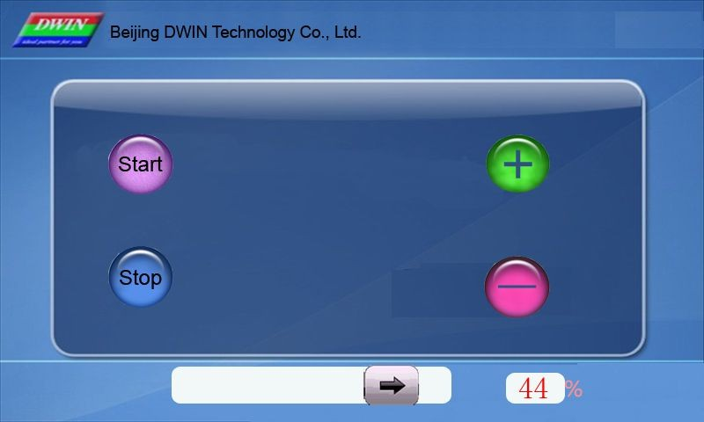

*Hold the button over 0.5 second and slide the slider to modify number in the right, the value will also be changed.*

## RTC

port.

**Selected Area:** selected button area.

**Preview:** preview button effect.

**Name:** name this button for viewing it in .xls file.

**Data Auto Upload:** after pressing the button, key code auto sent to serial

**Button Effect:** set picture ID for touching effect, -1: null.

**Display Position:** data position when typing.

**Font Color:** data color when typing. **Font Lib_ID:** address of ASCII font file. **Font Size:** horizontal pixel numbers.

**Cursor Color:** white/black cursor.

#### Keyboard setting:

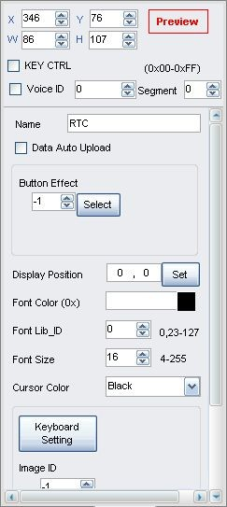Set the keyboard picture ID and the keyboard area.

**Image ID:** image ID of keyboard area.

**Cut Area:** cut area in image ID.

**Paste Position:** position of the keyboard on current screen. Notes: A keyboard setting is the same as <Data Input>.

Use <RTC display> or <Analog clock display> to display current time.

##### Professional, Creditable, Successful DGUS_SDK User Guide V5.1

*Il**lustration of button <RTC>:*

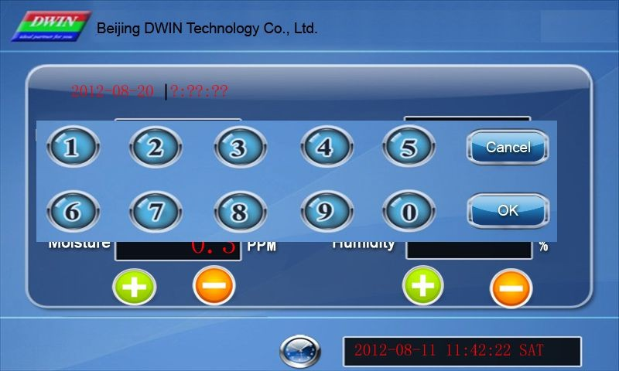

*Click <RTC> button - Keyboard Pops Up - Clock* *Sets Up the Current Time.*

## Basic Touch Control

**Selected Area:** selected button area.

**Preview:** preview button effect.

**Name:** name this button for viewing it in .xls file.

**Button Effect:** set picture ID for touching effect, -1: null.

**Jump To:** switch to a new picture after pressing.

#### KeyValue:

Only <Touch Control> button works on keyboard area. Valid key code range: 0x0030 - 0x0039 (0-9), 0x002E (.), 0x002D (+/-), 0x00F0 (Cancel), 0x00F1 (Confirm), 0x00F2 (Backspace).

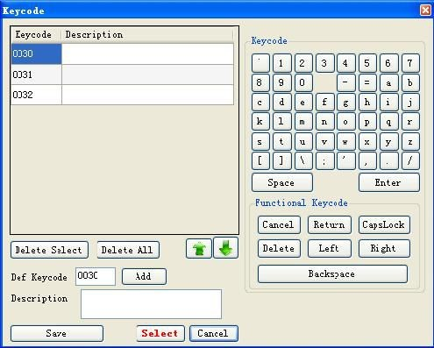

Professional, Creditable, Successful DGUS_SDK User Guide V5.1

## Return Key Code

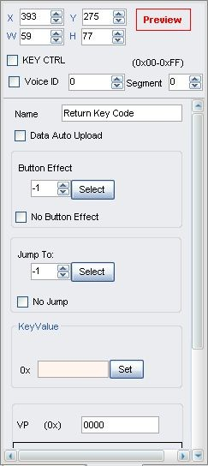

*Illustration of button <Return Key Code>:*

port.

**Selected Area:** selected button area.

**Preview:** preview button effect.

**Name:** name this button for viewing it in .xls file.

**Data Auto Upload:** after pressing the button, key code auto sent to serial

**Button Effect:** set picture ID for touching effect, -1: null.

**Jump To:** switch to a new picture after pressing.

**KeyValue:** self-defined keyValue for buttons.

**VP:** variable pointer.

#### VP Type:

Save in VP address.

Save in high byte of VP address. Save in low byte of VP address. Save in specified bit of VP address.

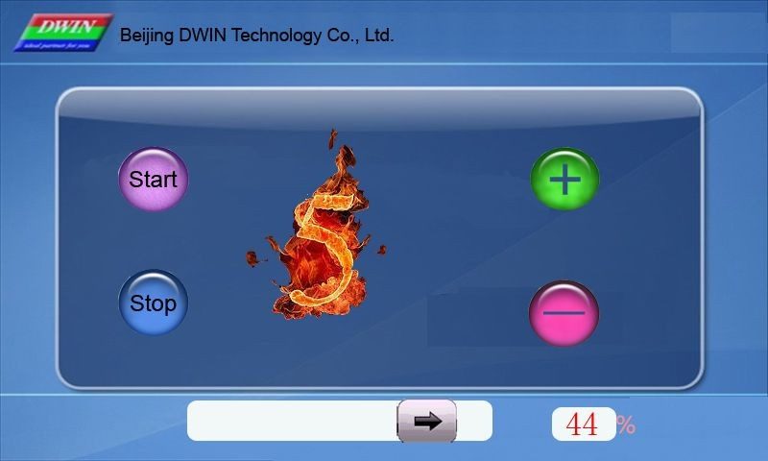

*Set a <Return Key Code> button, of which VP is 0x000A, key value is 0x0005.*

##### Professional, Creditable, Successful DGUS_SDK User Guide V5.1

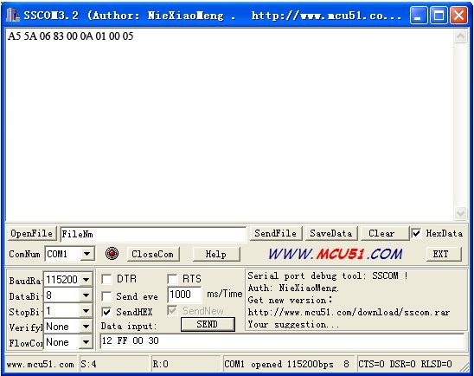

*DGUS module auto uploads data 0005 to serial port as shown.*

## ASCII Input

port.

**Selected Area:** selected button area.

**Preview:** preview button effect.

**Name:** name this button for viewing it in .xls file.

**Data Auto Upload:** after pressing the button, key code auto sent to serial

**Button Effect:** set picture ID for touching effect, -1: null.

**Jump To:** switch to a new picture after pressing.

**VP:** variable pointer.

**Text Length:** length of text, by word, range from 1 to 123.

**Input Mode:** re-input/ edit text.

**Font Lib_ID:** address of ASCII font file. **Font Width:** horizontal pixel numbers. **Font Height:** vertical pixel numbers.

**Cursor Color:** white/black.

**Font Color:** data color when typing.

**Upload value as typing:** tying status upload.

**Text Display Area:** data position on screen when typing.

**Keyboard Displayed in:** Current Page/Other Page.

#### Keyboard Setting:

Set the keyboard picture ID and the keyboard area.

**Image ID:** image ID of the keyboard area.

**Cut Area:** cut area in image ID.

**Paste Position:** position of the keyboard on current screen.

Note: Create <Touch control> buttons on keyboard to define the

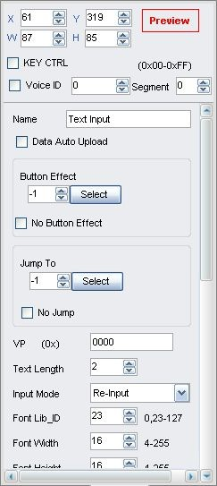key code of the button (0x4161 indicates “A”).

Inputted data can be displayed with <Text display> function.

Professional, Creditable, Successful DGUS_SDK User Guide V5.1

*Il**lustration of button <ASCII Input>:*

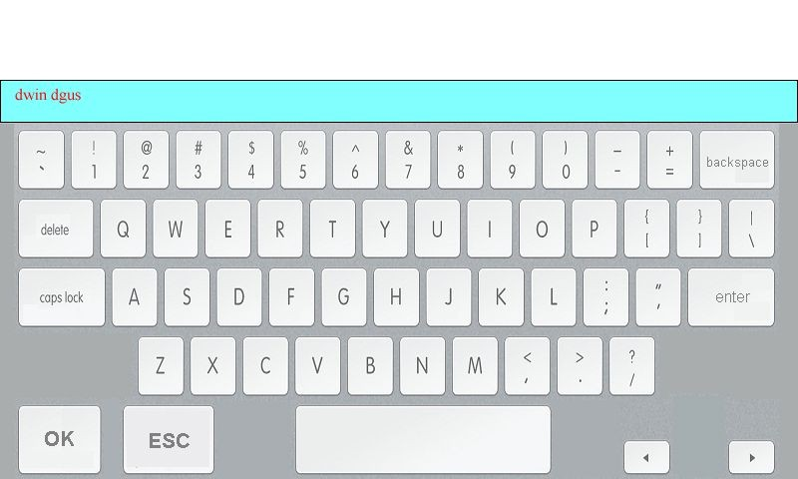

## Firmware Parameter Settings

**Selected Area:** selected button area.

**Preview:** preview button effect.

**Name:** name this button for viewing it in .xls file.

**Data Auto Upload:** after pressing the button, key code auto sent to

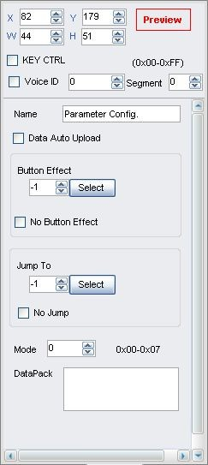serial port.

**Button Effect:** set picture ID for touching effect, -1: null.

**Jump To:** switch to a new picture after pressing.

**Mode:** setup mode. **DataPack:** data pack of setup. Setup Mode

Professional, Creditable, Successful DGUS_SDK User Guide V5.1

|  |  |  |  |
| --- | --- | --- | --- |
| **Mod e** | **Data Pack** | **Description** | **Function** |
| 0x00 | No | No | Transmit data from register to variable SRAM in 0x6F00 to 0x6FFF (low bytes). |
| 0x01 | No | No | Transmit data from address 0x6F00 to 0x6FFF in variable SRAM (low bytes) to register and reset module parameters including R1-R3, R5-RA. |
| 0x02 | Tran_Area | Coordinates of top-left and bottom-right of area. | Convert designated area to monochrome bitmap (vertical mode) and save the data to designated VP address.   1. Width (Xe-Xs+1) should be even. 2. Height (Ye-Ys+1) should be multiple of 8. 3. VP data format shown as below:   VP: status indicator, refreshed to 0x5555 after operation. VP+1: horizontal length, by word. (Xe-Xs+1) &0xFFFE/2 VP+2: numbers of data segment. (Ye-Ys+1) &0xFFF8/8 VP+3: bitmap data, with MSB priority.  If the key code automatically upload is enabled (R2.3=1), module will upload message (value in VP address upload to 0x5555) to serial port.  The command is mainly for printing of current screen. |
| *VP | VP address for restoring bitmap data. |
|  | |
| 0x03 | *VP | Variable pointer. | Upload data in designated VP address to serial port. Range of Tx_LEN: 0x0001-0xFFFF. |
| Tx_LEN | Length of data to be sent. |
| 0x04 | Same function with 0x03, uploading data to COM2 (reserved port). | | |
| 0x05 | Tran_Area | Coordinates of top-left and bottom-right of area. | Convert designated area to monochrome bitmap (horizontal mode) and save the data to designated VP address.   1. Width (Xe-Xs+1) should be multiple of 16. 2. VP data format as shown below:   VP: status indicator, refreshed to 0x5555 after operation. VP+1: horizontal length, by word. (Xe-Xs+1) &0xFFF0/16 VP+2: numbers of data segment. (Ye-Ys+1)  VP+3: bitmap data, with MSB priority.  If the key code automatically upload is enabled (R2.3=1), module will upload message (value in VP address upload to 0x5555) to serial port.  The command is mainly for printing of current screen. |
| *VP | VP address for restoring bitmap data. |
| 0x06 | Frame_Head | Frame header (2byte) | Send the current touched position to COM2 (serial port for reserving the system), the format is:  Frame_Head + X + Y + Check (The cumulative Sum for 1 byte of X, Y) + Frame_end. |
| Frame_End | Frame end (2byte) |

Professional, Creditable, Successful DGUS_SDK User Guide V5.1

## Status sync-returned

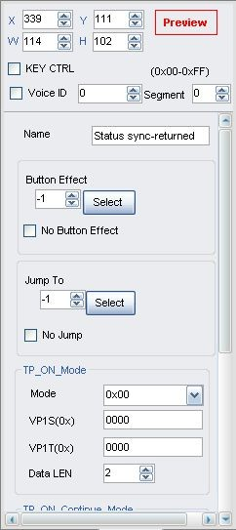**Selected Area:** (X, Y) are the top-left coordinates of icons.

**Preview:** preview VAR display effect.

**Name:** name this button for viewing it in .xls file.

**TP_ON_Mode:** commands returned with once touch.

**TP_ON_CONTINUE_Mode:** commands returned with freezing touch.

**TP_OFF_Mode:** commands returned with touch released. Status sync-returned mode

|  |  |  |  |
| --- | --- | --- | --- |
| **Add.** | **Definition** | **Data Length** | **description** |
| 0X00 | Pic_ID | 2 | Picture ID |
| 0X02 | TP_Area | 8 | The selected button area |
| 0X0A | Pic_Next | 2 | Switch to a new picture after  pressing,0XFF:null. |
| 0X0C | Pic_On | 2 | Picture ID for touching effect,0XFF:null. |
| 0X0E | TP_Code | 2 | 0XFE08 |
| 0X10 | 0xFE | 2 | 0XFE |
| 0X11 | TP_ON_Mode | 1 | Commands returned with one touch: 0X00=no commands returned; 0X01=read LEN1 length data from  VP1S , and write to VP1T variable adds; 0X02=read LEN1 length data from  VP1S, and write to the serial port; 0X03=read LEN1 length data from  VP1S, and write to VP1T register. |
| 0X12 | VP1S | 2 | Reading data adds of the first touch on the  touch screen. |

Professional, Creditable, Successful DGUS_SDK User Guide V5.1

|  |  |  |  |
| --- | --- | --- | --- |
| 0X14 | VP1T | 2 | Writing adds of the first touch on the touch  screen. |
| 0X16 | 0x00 | 1 | 0X00 |
| 0X17 | LEN1 | 1 | Length of the returning data(byte). 0X01=LEN1 must be an even  number. |
| 0X18 | 0xFE | 1 | 0XFE |
| 0X19 | TP_ON_Continue_Mode | 1 | Commands returned with a freezing touch:  0X00=no commands returned; 0X01=read LEN2 length data from  VP2S , and write to VP2T variable adds; 0X02=read LEN2 length data from  VP2S , and write to the serial port; 0X03=read LEN2 length data from  VP2S, and write to VP2T register. |
| 0X1A | VP2S | 2 | Reading data adds of the freezing touch  on the touch screen. |
| 0X1C | VP2T | 2 | writing data adds of the freezing touch on  the touch screen. |
| 0X1E | 0x00 | 1 | 0X00 |
| 0X1F | LEN2 | 1 | Length of the returning data(byte). 0X01=LEN2 must be an even  number. |
| 0X20 | 0xFE | 1 | 0XFE |
| 0X21 | TP_OFF_Mode | 1 | Commands returned with the button is released:  0X00=no commands returned; 0X01=read LEN3 length data from  VP3S , and write to VP3T variable adds; 0X02=read LEN3 length data from  VP3S , and write to the serial port; 0X03=read LEN3 length data from  VP2S, and write to VP3T register. |
| 0X22 | VP3S | 2 | Reading data adds when a button is  released. |
| 0X24 | VP3T | 2 | writing data adds of the freezing touch on  the touch screen. |
| 0X26 | 0x00 | 1 | 0X00 |
| 0X27 | LEN3 | 1 | Length of the returning data(byte). 0X01=LEN3 must be an even  number. |
| 0X28 | 0x00 | 8 | Reserved,0x00 as d. |

Professional, Creditable, Successful DGUS_SDK User Guide V5.1

## Variable Config.

## Variable Icon

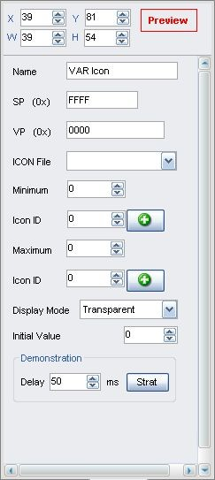

*Illustration of variable <Variable Icon>:*

**Selected Area:** (X, Y) are the top-left coordinates of icons.

**Preview:** preview VAR display effect.

**Name:** name this button for viewing it in .xls file.

**SP:** stack pointer, default setting is 0xFFFF.

Set SP to load description data into variable SRAM. 0xFFFF: load description data from configuration file. **VP:** variable pointer.

**ICON File:** address of icon file.

**Min/Max value:** limits of variables, null if over limit.

#### Icon ID:

Icon address in icon file corresponding to the min/max value.

**Display Mode:** transparent/background.

**Initial Value:** Set the initial value & save it in the 22 config file,the system will be initiated according to 22 config file when the DGUS is started.

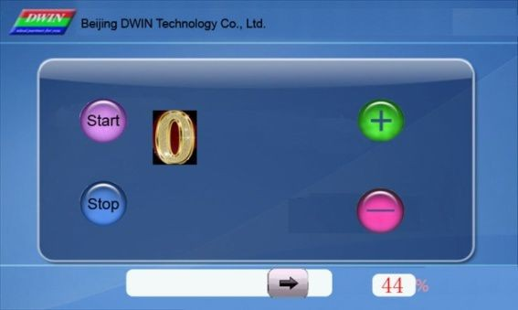 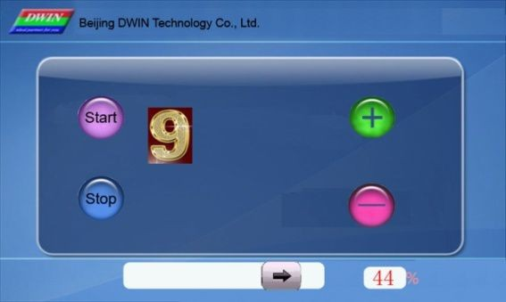

*Change the value in VP address to display different icons.*

Professional, Creditable, Successful DGUS_SDK User Guide V5.1

## Animation Icon

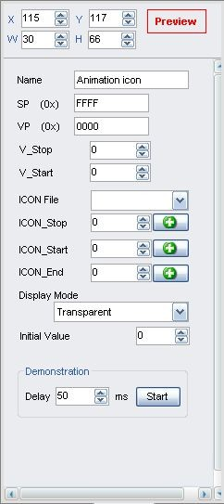**Selected Area:** (X, Y) are the top-left coordinates of icons.

**Preview:** preview VAR display effect.

**Name:** name this button for viewing it in .xls file. **SP:** stack pointer, default setting is 0xFFFF. **VP:** variable pointer.

**V_Stop:** set value to stop animation. **V_Start:** set value to start animation. **ICON File:** address of icon file.

**ICON Stop:** icon at V_stop value.

#### Icon_Start/Icon_End:

Start/end icon for animation at V_start Value.

**ICON Display Mode:** transparent/background.

**Initial Value:** Set the initial value & save it in the 22 config file,the system will be initiated according to 22 config file when the DGUS is started.

*Illustration of variable <Animation Icon>:*

*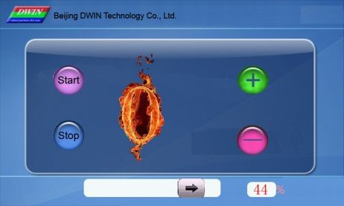When value in VP address is 0, screen display icon 0:*

*When value in VP address is 9, animation starts.*

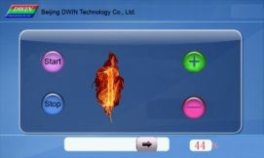...... 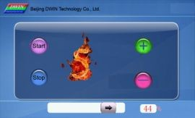 ...... 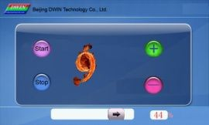

Professional, Creditable, Successful DGUS_SDK User Guide V5.1

## Slider

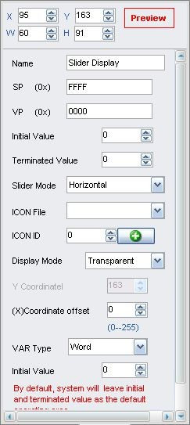**Selected Area:** (X, Y) are the top-left coordinates of icons. X, W is start/end point of horizontal slider.

Y, H is start/end point of vertical slider.

**Preview:** preview VAR display effect.

**Name:** name this button for viewing it in .xls file. **SP:** stack pointer, default setting is 0xFFFF. **VP:** variable pointer.

**Start/End Value:** value corresponding to start/end point.

**Slider Mode:** horizontal/vertical. **ICON File:** address of icon file. **ICON ID:** icon address in icon file.

**Display Mode:** transparent/background.

#### Coordinate Offset:

Offset to the left/top.

#### VAR Type:

Integer (whole VP address). High byte in VP address.

Low byte in VP address.

**Initial Value:** Set the initial value & save it in the 22 config file,the system will be initiated according to 22 config file when the DGUS is started.

###### Note: Set same VP address for <Slider> button and <Slider display> variable to combine them.

<Slider display> is also used as progress bar.

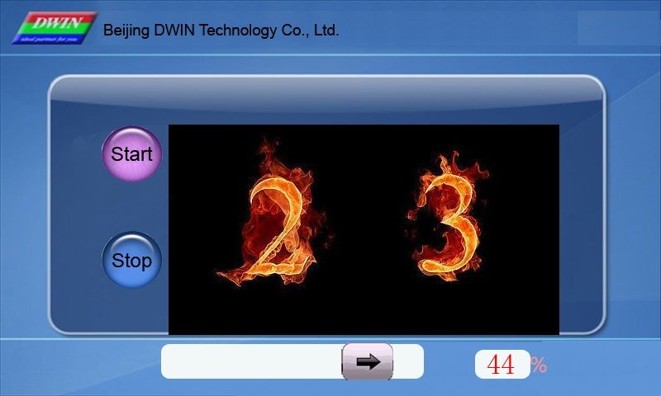

*Send command to serial port:*

Frame header, Length, Command, VP, Data *string to display the Slider and Data above.*

A5 5A 05 82 000C 002C

Professional, Creditable, Successful DGUS_SDK User Guide V5.1

## WordArt

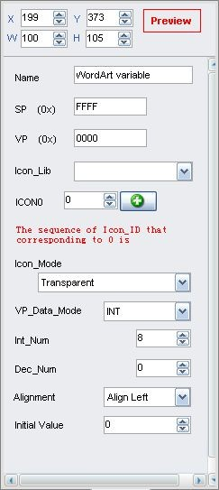

*Illustration of variable <WordArt >:*

**Selected Area:** (X, Y) are the top-left coordinates of icons.

**Preview:** preview VAR display effect.

**Name:** name this button for viewing it in .xls file. **SP:** stack pointer, default setting is 0xFFFF. **VP:** variable pointer.

**ICON File:** address of icon file.

**ICON 0:** icon address corresponding to number 0. **ICON Display Mode:** transparent/background. **VAR Type:** integer/long integer.

**Number of INT/DEC bit:** length of integer/decimal digits.

**Initial Value:** Set the initial value & save it in the 22 config file,the system will be initiated according to 22 config file when the DGUS is started.



*Send command to serial port:*

Frame header, Length, Command, VP, Data *string to display the WordArt above.*

A5 5A 05 82 0CCC 0017

Professional, Creditable, Successful DGUS_SDK User Guide V5.1

## Image Animation

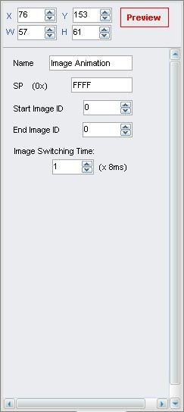**Selected Area:** (X, Y) are the top-left coordinates of icons.

**Preview:** preview VAR display effect.

**Name:** name this button for viewing it in .xls file.

**SP:** stack pointer, default setting is 0xFFFF.

**Start Image ID:** select starting picture of animation. **End Image ID:** select ending picture of animation. **Image Switching Time:**

Select switching speed for animation, by every 8ms. Start image ID should be less than end image ID. Set a <image animation> on end image to loop.

Send commands or set <touch control> button to interrupt animation.

Professional, Creditable, Successful DGUS_SDK User Guide V5.1

## Icon Rotation

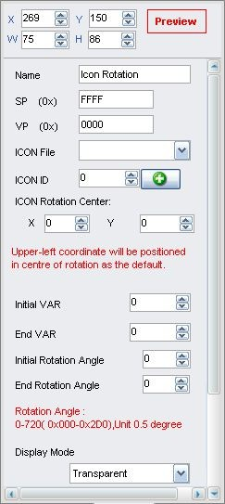

*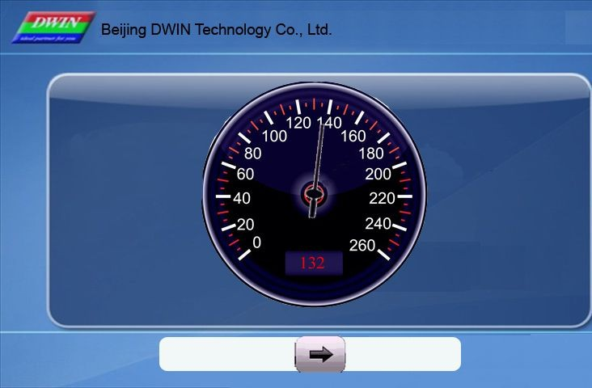Illustration of variable <Icon Rotation >: Icons file for rotation:*

**Selected Area:** (X, Y) are the coordinates of rotating center.

**Preview:** preview VAR display effect.

**Name:** name this button for viewing it in .xls file.

**SP:** stack pointer, default setting is 0xFFFF.

**VP:** variable pointer.

**ICON File:** address of icon file. **ICON ID:** icon address in icon file. **ICON Rotation Center:**

Select rotation center (X, Y) for the icon.

#### Initial/End VAR Value:

Value corresponding to start/end angle, null if over limit.

#### Initial/End Rotation Angle:

Select start/end angle, ranging from 0 to 720, by every 0.5°.

**Display Mode:** transparent/background.

#### VP_Mode:

Integer (whole VP address). High byte in VP address.

Low byte in VP address.

**Initial Value:** Set the initial value & save it in the 22 config file,the system will be initiated according to 22 config file when the DGUS is started.

##### Send serial commands or press buttons to change value in VP address, and then to adjust the angle of pointer.



*Send command to serial port:*

Frame header, Length, Command, VP, Data *string to display the ICON above.*

A5 5A 05 82 000A 0084

Professional, Creditable, Successful DGUS_SDK User Guide V5.1

## Data Variable

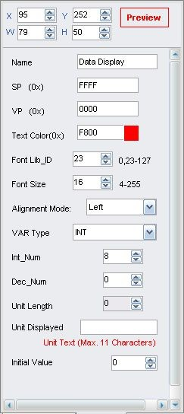

*Illustration of variable <Data Variable>:*

**Selected Area:** (X, Y) are the top-left coordinates of data.

**Preview:** preview VAR display effect.

**Name:** name this button for viewing it in .xls file. **SP:** stack pointer, default setting is 0xFFFF. **VP:** variable pointer.

**Font Color:** data color.

**Font Lib_ID:** address of ASCII font file.

**Font Size:** horizontal pixel numbers. **Alignment Mode:** Right/Left /Centered. **VAR Type:**

0x00: integer. 0x01: long integer.

0x02: high byte in VP address. 0x03: low byte in VP address.

**Number of INT Bit:** length of integer digits.

**Number of DEC Bit:** length of decimal digits.

#### Unit Length:

Corresponding to displayed unit automatically.

#### Unit Displayed:

ASCII unit for data, max length is 11 bytes.

**Initial Value:** Set the initial value & save it in the 22 config file,the system will be initiated according to 22 config file when the DGUS is started.

##### Send commands or set buttons to modify displayed data.

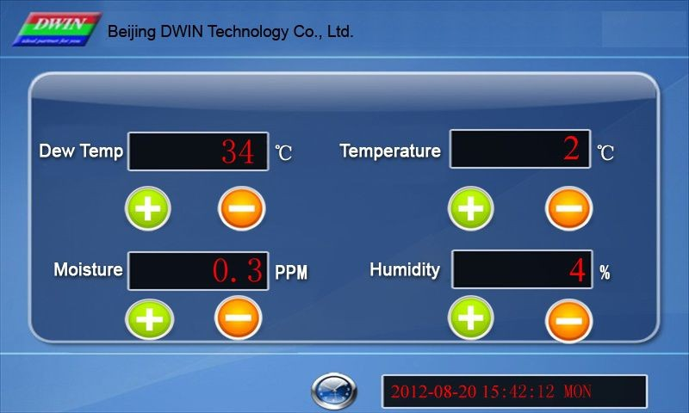

*Send command to serial port:*

Frame header, Length, Command, VP, Data *string to display the Data (left-up) above.*

A5 5A 05 82 0000 0022

Professional, Creditable, Successful DGUS_SDK User Guide V5.1

## Text Display

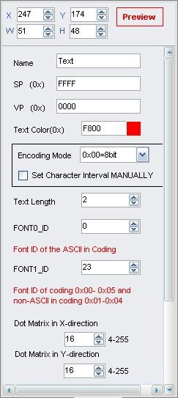

*Illustration of variable <Text Display>:*

**Selected Area:** (X, Y) are top-left coordinates of data. Textbox is the selected area.

**Preview:** preview VAR display effect.

**Name:** name this button for viewing it in .xls file. **SP:** stack pointer, default setting is 0xFFFF. **VP:** variable pointer.

**Text Color:** data color.

#### Encoding Mode:

0x00: 8bit encoding, 0x01: GB2312, 0x02: GBK, 0x03:BIG5, 0x05: UNICODE.

#### Set Character Interval MANUALLY: on/off.

**Text Length:** select text length, by byte.

**Font0_ID:** address of ASCII font file.

**Font1_ID:** address of non-ASCII font file.

**Dot Matrix in X/Y-direction:** select font size. Please note that parameter should be the same with the size of font file.

#### Horizontal/Vertical Separation:

Pixel distance in Horizontal/Vertical.

**Initial Value:** Set the initial value & save it in the 22 config file,the system will be initiated according to 22 config file when the DGUS is started.

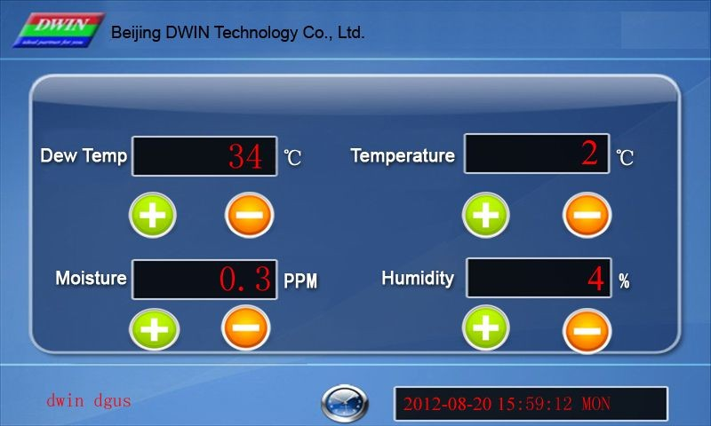

*Send command to serial port:*

Frame header, Length, Command, VP, Data *string to display the Text (bottom-left) above.*

A5 5A 0D 82 0008 64 77 69 6E 20 64 67 75 73 76

Professional, Creditable, Successful DGUS_SDK User Guide V5.1

## Digital RTC Display

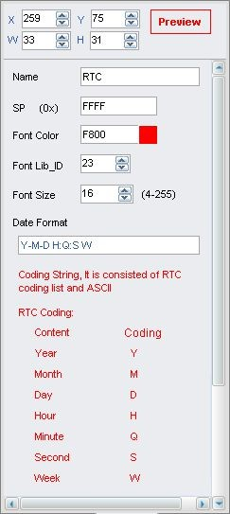**Selected Area:** (X, Y) are the top-left coordinates of data.

**Preview:** preview VAR display effect.

**Name:** name this button for viewing it in .xls file. **SP:** stack pointer, default setting is 0xFFFF. **Font Color:** data color.

**Font Lib_ID:** address of ASCII font file.

**Font Size:** horizontal pixel numbers.

**Date Format:** refer to the red texts in picture in the left.

##### Use <RTC> button to modify current time.

*llustration of variable <Digital RTC Display> (Digital clock on bottom-right of screen):*

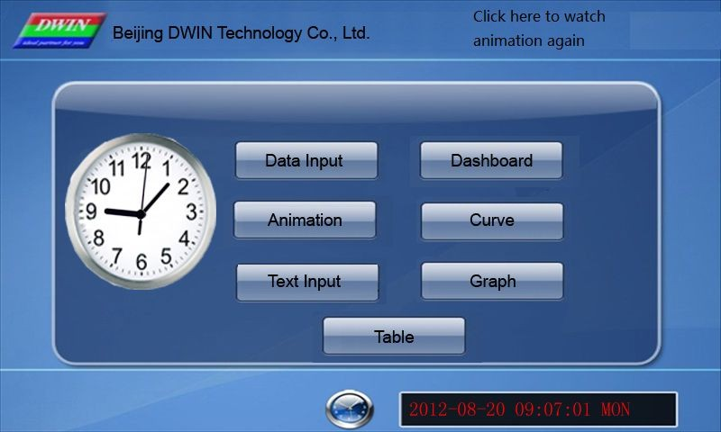

Professional, Creditable, Successful DGUS_SDK User Guide V5.1

## Analog Clock Display

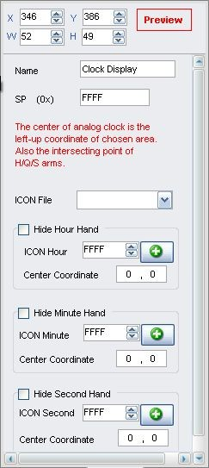

*Illustration of variable <Analog Clock Display>:*

**Selected Area:** (X, Y) are the rotating center coordinates.

**Preview:** preview VAR display effect.

**Name:** name this button for viewing it in .xls file. **SP:** stack pointer, default setting is 0xFFFF. **ICON File:** address of icon file.

#### Analog Clock:

**ICON Hour:** select hour hand ID in icon file. **Center Coordinate:** rotation center in icon. **Minute Hand:**

**ICON Minute:** select minute hand ID in icon file.

**Center Coordinate:** rotation center in icon.

#### Second Hand:

**ICON Second:** select second hand ID in icon file.

**Center Coordinate:** rotation center in icon. Use <RTC> button to modify current time.



Professional, Creditable, Successful DGUS_SDK User Guide V5.1

## Dynamic Trend Curve

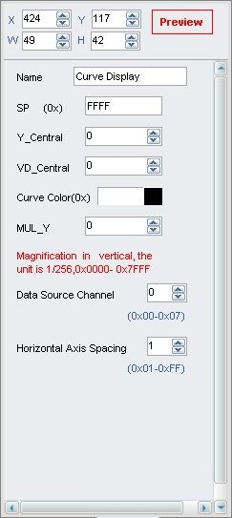**Selected Area:** select window area, null if over range.

**Preview:** preview VAR display effect.

**Name:** name this button for viewing it in .xls file. **SP:** stack pointer, default setting is 0xFFFF. **Y_Central:** select center line of trend curve.

#### VD_Central:

Trend curve value at center line, normally average of Max & Min value.

**Curve Color:** select color for trend curve.

**MUL_Y:** magnification in Y direction, by every 1/256. **Data Source Channel:** select channel for trend curve. **Horizontal Spacing:**

Transverse spacing between sampling points.

*Illustration of variable <Dynamic Trend Curve Display>:*

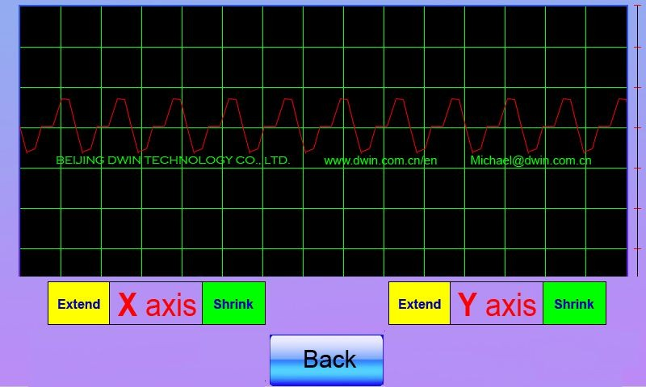

*Send command to serial port:*

Frame header, Length, Command, Data channel, Data *string to display the trend curve above.*

A5 5A 18 84 01 0800 0700 0710 0733 0800 0800 0800

0800 0900 0908 0906

Professional, Creditable, Successful DGUS_SDK User Guide V5.1

## Table Display

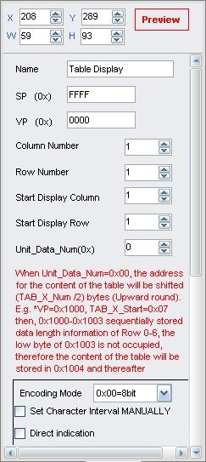

*Illustration of variable <Table Display>:*

**Selected Area:** select table area, null if over range.

**Preview:** preview VAR display effect.

**Name:** name this button for viewing it in .xls file.

**SP:** stack pointer, default setting is 0xFFFF.

**VP:** variable pointer, starting address of the data in table.

**Column/Row Number:** set the size of table.

#### Start Display Column/Row:

Select starting column/row to be displayed.

#### Unit_Data_Num:

0x01-0x7F: length of data for one cell.

0x00: data in VP address defines the length of each column.

When Unit_Data_Num is 00, starting address of data will be (Row number/2, round up to integer) backward from VP address.

#### Encoding Mode:

0x00: 8bit, 0x01: GB2312, 02: GBK, 03: BIG5, 04: SJIS, 05: UNICODE.

#### Set Character Interval MANUALLY: on/off.

**Boarder Color:** select table boarder color.

**Text Color:** select text color.

**FONT0_ID:** address of ASCII font file. **FONT1_ID:** address of none-ASCII font file. **X/Y-Direction Size:**

Select font size, accordant with width of fonts in font file.

**Column Header:** Valid Display/Invalid Display.

**Row Header:** Valid Display/Invalid Display.

Data for table can be loaded by 22.bin file. Refer to DGUS document for detailed instruction.

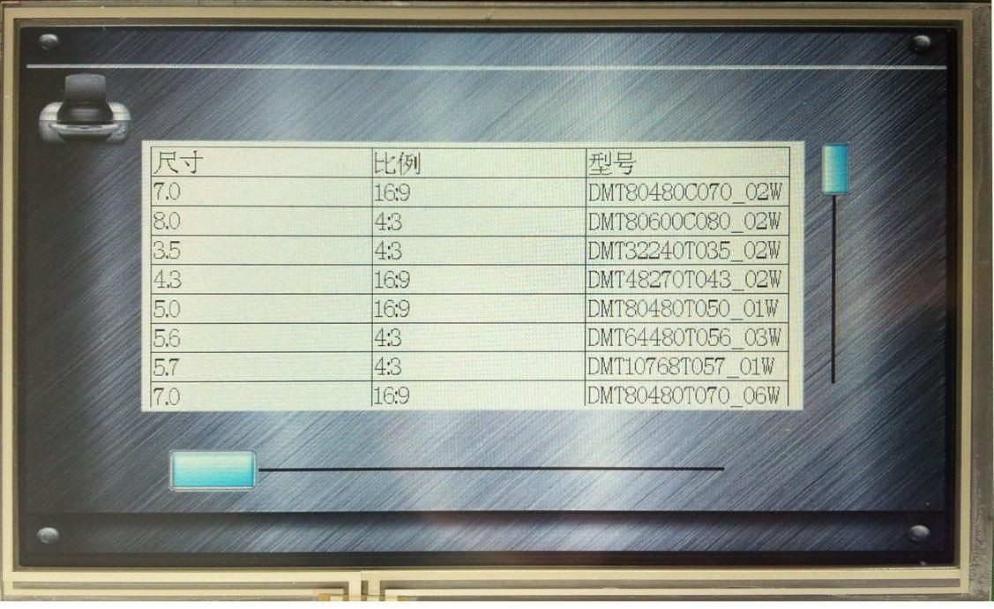

##### Professional, Creditable, Successful DGUS_SDK User Guide V5.1

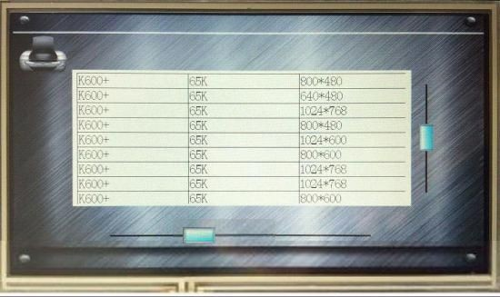

*If the* *length of data is shorter than designated, please use 0xFFFF as end mark of data in this cell. For oversized table, users can use slider to pull the table.*

## Basic Graphic Display

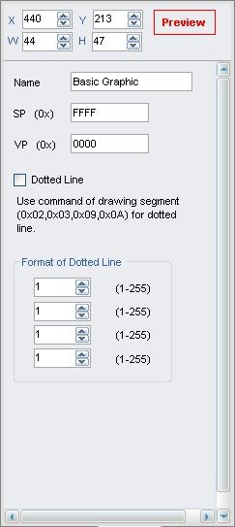**Selected Area:** select window area, null if over range. (Limit is only effective for 0x0001 - 0x0005 commands).

**Name:** name this button for viewing it in .xls file. **SP:** stack pointer, default setting is 0xFFFF. **VP:** variable pointer.

Professional, Creditable, Successful DGUS_SDK User Guide V5.1

String Format

|  |  |  |
| --- | --- | --- |
| **Address** | **Definition** | **Description** |
| VP | CMD | Command |
| VP+1 | Data_Pack_Num_Max | Data Pack Number |
| VP+2 | DATA_Pack |  |

Data Pack for Basic Graphic

|  |  |  |  |  |  |
| --- | --- | --- | --- | --- | --- |
| **CMD** | **Function** | **Description of Data Pack Format, by word** | | | |
| **Relative Address** | **Length** | **Definition** | **Description** |
| 0x0001 | Dot | 0x00 | 2 | (x, y) | Dot coordinates. |
| 0x02 | 1 | Color | Dot color. |
| 0x0002 | Line | 0x00 | 1 | Color | Line color. |
| 0x01 | 2 | (x, y)0 | Vertex 0 coordinates. |
| 0x03 | 2 | (x, y)1 | Vertex 1 coordinates. |
| 0x01+2*n | 2 | (x, y)n | Vertex n coordinates. |
| 0x0003 | Rectangle | 0x00 | 2 | (x, y)s | Top-left coordinates. |
| 0x02 | 2 | (x, y)e | Bottom-right coordinates. |
| 0x04 | 1 | Color | Rectangle’s color. |
| 0x0004 | Rectangle Area Fill | 0x00 | 2 | (x, y)s | Top-left coordinates. |
| 0x02 | 2 | (x, y)e | Bottom-right coordinates. |
| 0x04 | 1 | Color | Filled color. |
| 0x0005 | Circle | 0x00 | 2 | (x, y) | Circle center coordinates. |
| 0x02 | 1 | Rad | Radius of circle. |
| 0x03 | 1 | Color | Circle color. |
| 0x0006 | Picture cut/paste | 0x00 | 1 | Pic_ID | Image ID of cutting area. |
| 0x01 | 2 | (x, y)s | Top-left coordinates of the cutting area. |
| 0x03 | 2 | (x, y)e | Bottom-right coordinates of the cutting area. |
| 0x05 | 2 | (x, y) | Paste position on current screen. |
| 0x**07 | Icon Display | 0x00 | 2 | (x, y) | Top-left coordinates of icon. |
| 0x02 | 1 | ICON_ID | Icon ID in icon file, high byte of command specifies address of icon file, display mode is transparent. |
| 0x0008 | Area fill | 0x00 | 2 | (x, y) | Sampling dot coordinates. |
| 0x02 | 1 | COLOR | Filled color. |
| 0x0009 | Vertical line | 0x00 | 1 | Color0 | Connect (X0, Y0s) (X0, Y0e) with color 0 |
| 0x01 | 1 | X0 |
| 0x02 | 1 | Y0s |
| 0x03 | 1 | Y0e |

###### Judging condition:

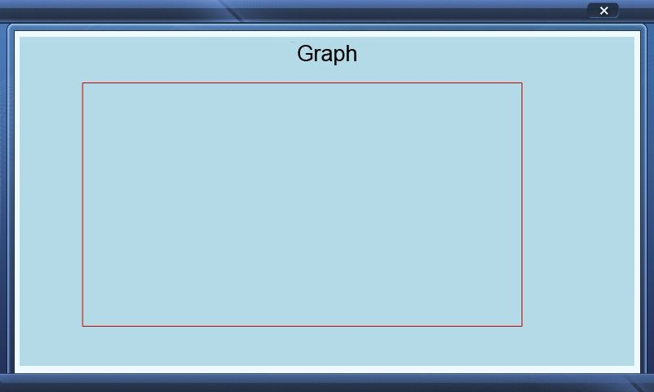0xFF: finish operation, 0xFE: skip to next step.

*Send command to serial port:*

###### Frame header, Length, Command, Address, Controlling bytes, Data pack, Coordinate, Color A5 5A 11 82 20 00 00 03 00 01 00 64 00 64 02 8C 01 90 F8 00

*To get the rectangle above.*

Professional, Creditable, Successful DGUS_SDK User Guide V5.1

## Special Industrial Application

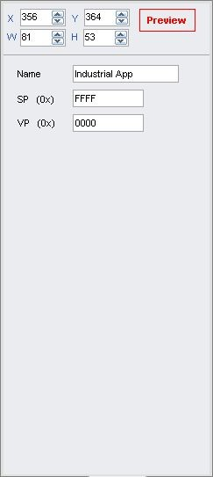**Name:** name this button for viewing it in .xls file.

**SP:** stack pointer, default setting is 0xFFFF.

**VP:** variable pointer.

String Format

|  |  |  |
| --- | --- | --- |
| **Address** | **Definition** | **Description** |
| VP | CMD | Command |
| VP+1 | Data_Pack_Num_Max | Data Pack Number |
| VP+2 | DATA_Pack |  |

Data pack for Special Industrial Application

|  |  |  |  |  |  |
| --- | --- | --- | --- | --- | --- |
| **CMD** | **Function** | **Description of data pack format, by word** | | | |
| Relative Address | Length | Definition | Description |
|  |  | 0x00 | 1 | Color0 | Color of “Safe Zone”. |
|  |  | 0x01 | 1 | Color1 | Color of normally overlapped area |
|  |  | (Overlapped once). |
|  |  | 0x02 | 1 | Color2 | Color of High-Risk overlapped area |
|  |  | (Overlapped twice or more). |
|  | Overlapped | 0x03 | 1 | Color3 | Color of circles. |
| 0x0001 | Area of Multiple | 0x04 | 1 | Color4 | Color of evasion. |
|  | Circles Fill | 0x05 | 4 | Disp_Area | Display area, null if over range. |
|  |  | 0x09＋4*n | 2 | (x, y)n | Center coordinates of No. n. |
|  |  | 0x0B＋4*n | 1 | RADn_1 | The bigger radius of No. n concentric |
|  |  | circles. |
|  |  | 0x0C＋4*n | 1 | RAD2n_2 | The smaller radius of No. n concentric |
|  |  | circles. |

Professional, Creditable, Successful DGUS_SDK User Guide V5.1

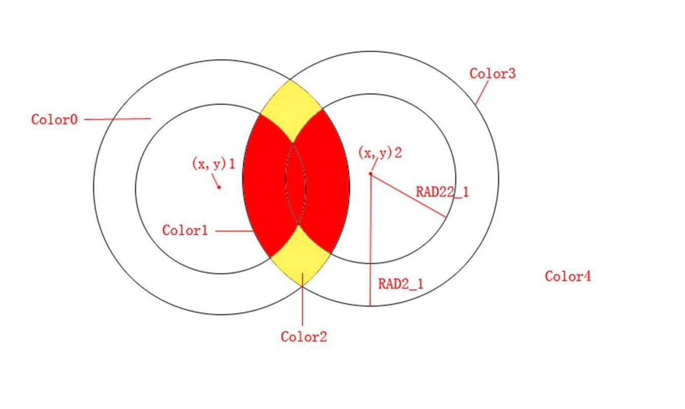

## Bit Variable Icon

**Selected Area:** (X, Y) are coordinates of top-left of icons.

**Preview:** preview VAR display effect.

**Name:** name this button for viewing it in .xls file. **SP:** stack pointer, default setting is 0xFFFF. **VP:** variable pointer.

**AP:** substitutive variable pointer, reserved 2 words. **Bit Icon ON (1) /OFF (0):** define BITs to display. **Disp. Mode:** shown as the following table.

#### Align Mode:

0x00: X++, space unreserved for undesignated bits. 0x01: Y++, space unreserved for undesignated bits. 0x02: X++, space reserved for undesignated bits. 0x03: Y++, space reserved for undesignated bits.

**Interval:** spacing between icons. **Icon File ID:** address of icon file. **ICON0S:**

Icon ID for bit0 in non-animation mode, or starting Icon ID for bit0 in animation mode.

**ICON0E:** ending icon ID for bit0 in animation mode.

#### ICON1S:

Icon ID for bit1 in non-animation mode, or starting Icon ID for bit1 in animation mode.

**ICON1E:** ending icon ID for bit1 in animation mode.

**ICON Mode:** Transparent/Opaque.

**Initial Value:** Set the initial value & save it in the 22 config file,the system will be initiated according to 22 config file when the DGUS is started.

##### Professional, Creditable, Successful DGUS_SDK User Guide V5.1

|  |  |  |
| --- | --- | --- |
| **Display_Mode** | **Value of bit** | |
| **0** | **1** |
| 0x00 | ICON0S | ICON1S |
| 0x01 | ICON0S | Null. |
| 0x02 | ICON0S | Animation: ICON1S - ICON1E. |
| 0x03 | Null. | ICON1S |
| 0x04 | Null. | Animation: ICON1S - ICON1E. |
| 0x05 | Animation: ICON0S - ICON0E. | ICON1S |
| 0x06 | Animation: ICON0S - ICON0E. | Null. |
| 0x07 | Animation: ICON0S - ICON0E. | Animation: ICON1S - ICON1E. |

*Illustration of variable <Bit Icon> (on bottom of screen):*

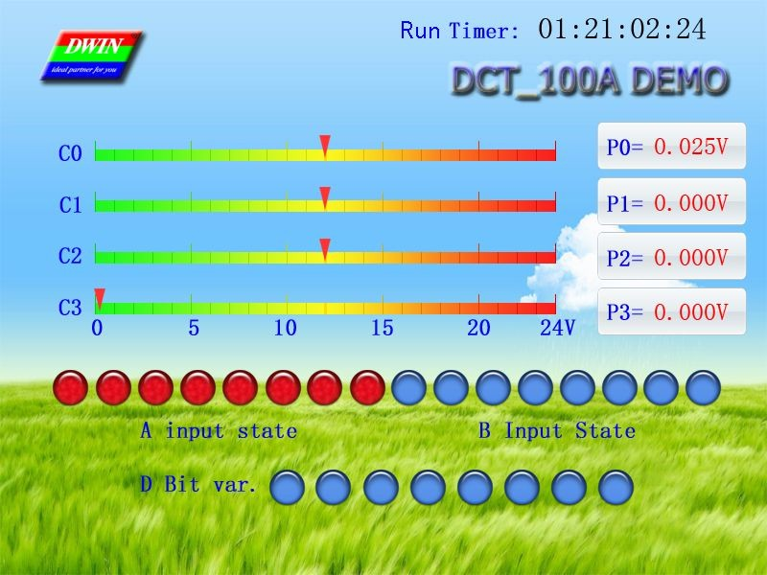

Professional, Creditable, Successful DGUS_SDK User Guide V5.1

## Timer Variable

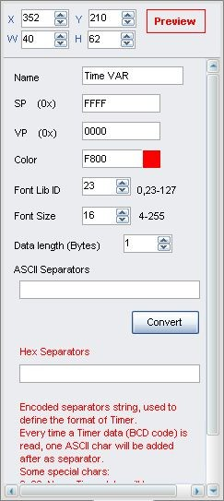**Selected Area:** (X, Y) are the top-left coordinates of data.

**Preview:** preview VAR display effect.

**Name:** name this button for viewing it in .xls file. **SP:** stack pointer, default setting is 0xFFFF. **VP:** variable pointer.

**Color:** data color.

**Font Lib ID:** address of font file, 8bit encoding half-width.

**Font Size:** font size in X-direction.

**Data length (Bytes):** byte numbers to be displayed.

**ASCII Separators:** data string.

**Convert:** convert ASCII Separators into Hex Separators.

Encoded separators string, used to define the format of Timer. Every time a Timer data (BCD code) is read, one ASCII char will be added after as separator.

Some special chars: 0x00: none, Timer data will be concatenated; 0x0D: new

line.

*Illustration of variable <Bit Icon> (on top-right of screen):*

**

Professional, Creditable, Successful DGUS_SDK User Guide V5.1

## RollText

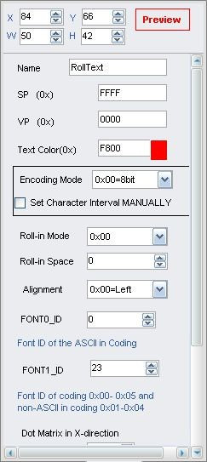**Selected Area:** (X, Y) are the top-left coordinates of data.

**Preview:** preview VAR display effect.

**Name:** name this button for viewing it in .xls file. **SP:** stack pointer, default setting is 0xFFFF. **VP:** variable pointer.

**Text Color**: data color.

#### Encoding Mode:

0x00: 8bit encoding, 0x01: GB2312,

0x02: GBK,

0x03:BIG5,

0x05: UNICODE.

#### Set Character Interval MANUALLY: on/off.

**Roll-in Mode:**

0X00=right to left 0X01=left to right 0X02=top to bottom 0X03=bottom to top

**Roll-in Space:** pixels to roll in each DGUS period.

**Alignment:** centered, left-aligned, right-aligned, top-aligned, button-aligned, equal width, equal height.

**Font0_ID:** address of ASCII font file.

**Font1_ID:** address of non-ASCII font file.

**Dot Matrix in X/Y-direction:** select font size. Please note that parameter should be the same with the size of font file.

#### Horizontal/Vertical Separation:

Pixel distance in Horizontal/Vertical.

**Initial Value:** Set the initial value & save it in the 22 config file,the system will be initiated according to 22 config file when the DGUS is started.

Professional, Creditable, Successful DGUS_SDK User Guide V5.1

# Commands

## Data Frame

Serial data frame is constituted with 5 parts as shown in chart below:

|  |  |  |  |  |  |
| --- | --- | --- | --- | --- | --- |
| **Data Block** | 1 | 2 | 3 | 4 | 5 |
| **Definition** | Frame header | Data length | Command type | Data string | CRC checksum |
| **Data Length** | 2 | 1 | 1 | N | 2 |
| **Description** | Defined by  R3  and RA parameter  in config.txt | Including command type, data string and CRC checksum | 0x80-0x84 |  | Enabled by R2 parameter in config.txt |

## Command Set

|  |  |  |  |  |  |
| --- | --- | --- | --- | --- | --- |
| **Function** | **CMD** | **Data** | **Description** | | |
| **Access Register** | 0x80 | ADR(0x00-0xFF)+Data_Pack | Write data in particular address of register | | |
| 0x81 | ADR(0x00-0xFF)+ RD_LEN(0x00-0xFF) | Read data in particular address of register | | |
| ADR(0x00-0xFF)+RD_LEN+  Data_Pack | Response of DWIN LCD module | | |
| **Access Variable SRAM** | 0x82 | ADR_H:(0x0000-0x6FFF)+DAT  A0…  +DATAn | Write data in particular address of variable SRAM | | |
| 0x83 | ADR_H: L(0x0000-0x6FFF)+ RD_LEN(0x00-0x7F) | Read data in particular address of variable SRAM | | |
| ADR_H: L+RD_LEN+DATA0……+  DATAn | Response of DWIN LCD module | | |
| **Trend Curve Buffer** | 0x84 | CH_Mode(Byte)+DATA0(Word)+…+ DATAn | Write trend curve buffer.  CH_Mode defines the channels of data :   * Each bit in CH_Mode corresponds to one channel. * CH_Mode. 0 corresponds to channel 0. * Low channel ranges ahead. * E.g.:   CH Mode=0x83(10000011B),   * data format like | | |
| "CH7 | +CH1 | +CH0" |

Register is accessed by every byte, variable SRAM and trend curve buffer is accessed by word.

## Register

##### Register, 256 bytes, is used for hardware operation and process control.

|  |  |  |  |
| --- | --- | --- | --- |
| **Register Address** | **Definition** | **Length (Byte)** | **Description** |
| 0x00 | Version | 1 | DGUS version number, BCD code, 0x10 indicates V1.0. |
| 0x01 | LED_NOW | 1 | LED brightness, 0x00-0x40. |
| 0x02 | BZ_TIME | 1 | Buzzer beeping time, by every 10ms. |
| 0x03 | PIC_ID | 2 | Read: read current picture ID. Write: switch to specific picture ID. |
| 0x05 | TP_Flag | 1 | 0x5A: there is update of touching area. Others= no updating.  TouchPanel data is no longer updated if user did not clear the flag |

##### Professional, Creditable, Successful DGUS_SDK User Guide V5.1

|  |  |  |  |  |
| --- | --- | --- | --- | --- |
|  |  |  | after data retrieving. | |
| 0x06 | TP_Status | 1 | 0x01: first click. 0x03: pressing down. 0x02: uplift pressing. Others: null. | |
| 0x07 | TP_Position | 4 | Coordinate of touching position: X_H:L, Y_H:L. | |
| 0x0B | TPC_Enable | 1 | 0x00: disable the touchPanel. Others: enable the touchPanel.  Default setting: 0xFF. | |
| 0x0C-0x0F | Reserve | 4 | Undefined. | |
| 0x10-0x1A | R0-RA | 11 | Mapping of SD card config. register, read only. | |
| 0x1F | RTC_COM_ADJ | 1 | 0x5A: RTC data is rewritten through serial port, cleared after RTC auto updating. | |
| 0x20 | RTC_NOW | 16 | YY:MM:DD:WW:HH:MM:SS | |
| Send serial command to modify current time, e.g.: A5 5A 0A 80 1F 5A 12 10 25 0412 00 01. “04” means Thursday, it can be written as any day you choose. | | | | |
| 0x30-0x3F | Reserve | 16 | Undefined. | |
| 0x40 | En_Lib_OP | 1 | 0x5A: applying writing in font flash memory, clear after operation. | |
| 0x41 | Lib_OP_Mode | 1 | 0x50: Transfer data from variable SRAM to font flash memory. 0xA0: Transfer data from font flash memory to variable SRAM. | |
| 0x42 | Lib_ID | 1 | Designate font address for data exchange. Total space are 16MB, font space: 0x40-0x7F, maximum space of every font is 128KW. | |
| 0x43 | Lib_Address | 3 | Designate address in font library for data exchange. Specified the first (word) address for data operation in font storage, 0x00:00:00-0x01:FF:FF. | |
| 0x46 | VP | 2 | Designate variable SRAM addresses for data exchange. Specified the first (word) address for data operation in font storage, 0x00:00-0x6F:FF. | |
| 0x48 | OP_Length | 2 | Length of exchanged data, by word. | |
| Save 1KW variable data string starting from 0x1000 address into #64 font ID with starting 0x0000 address, send serial command: A5 5A 0C 80 40 5A 50 40 00 00 00 10 00 02 00. | | | | |
| 0x4A | Timer0 | 2 | 16-bit software timer, in term of 4ms, auto-decrement to 0. | Maximum error is  +/_4ms. |
| 0x4C | Timer1 | 1 | 8-bit software timer, in term of 4ms, auto-decrement to 0. |
| 0x4D | Timer2 | 1 | 8-bit software timer, in term of 4ms, auto-decrement to 0. |
| 0x4E | Timer3 | 1 | 8-bit software timer, in term of 4ms, auto-decrement to 0. |
| 0x4F | Key_code | 1 | Address of key code for 13 touch control config. file, 0x00: null. Clear after operation executed. | |
| 0x50-0xFF | Reserve | 182 | Undefined. | |

Register is accessed by command 0x80/0x81.

**DGUS Register Space**: 0x00H-0xFFH, is written / read by byte.

**DGUS Variable Data Memory Space:** 0x0000H-0x6FFFH, is written / read by word. Data in Curve buffer is written / read by word.

The communication between DGUS LCMs & Controllers (MCU) are driven by Variables that you may read and write in corresponding address.

Professional, Creditable, Successful DGUS_SDK User Guide V5.1

## VP & SP

## VP (Variable Pointer)

* + - 1. **About VP**

VP is the initial address of variables in variable SRAM (56KB) which separated into 28672 pcs of memory spaces from 0x0000 to 0x6FFF occupying two bytes for each below. (High bytes and Low bytes)

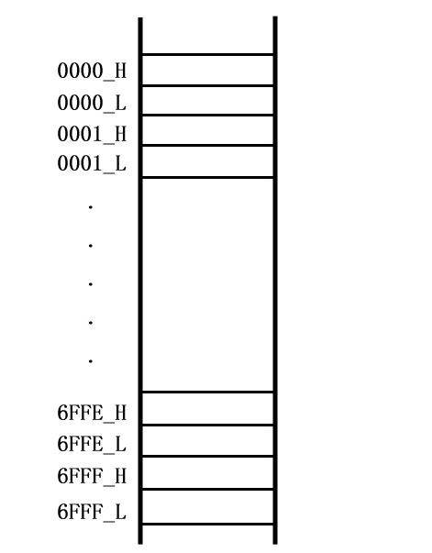

***Starting Address***

***Length***

The communication between DGUS LCMs and host is oriented by variables that you may read or write in corresponding address. Reading &Writing of initial address and variable length could be changed via Command 0x82&0X83 if known in advance.

## How to use VP?

### Assign VP for each variables

Each variable should be assigned a VP, yet overlap is not allowed. The value of the variable will be saved from the VP. For example, variable 1 as a long integer saved in 0x1001 while variable 2 as an integer have to be stored on another address preventing 0x1001 and 0x1002 from conflicts with variable 1.

***VP of variable 1 0x1001***

***VP of variable 2 0x1003***

***Length of variable 1 2 words***

***Length of variable 2 2 words***

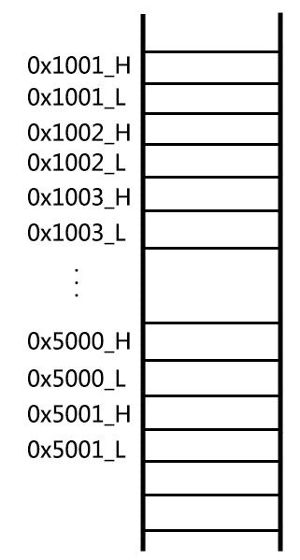

Professional, Creditable, Successful DGUS_SDK User Guide V5.1

### Set VP via DGUS_SDK

For example, display and input a variable (No. 100) which is an integer. The VP of this variable is 0x1000.

***VP***

***Length***

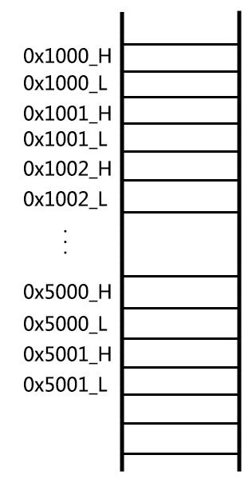

**00**

**64**

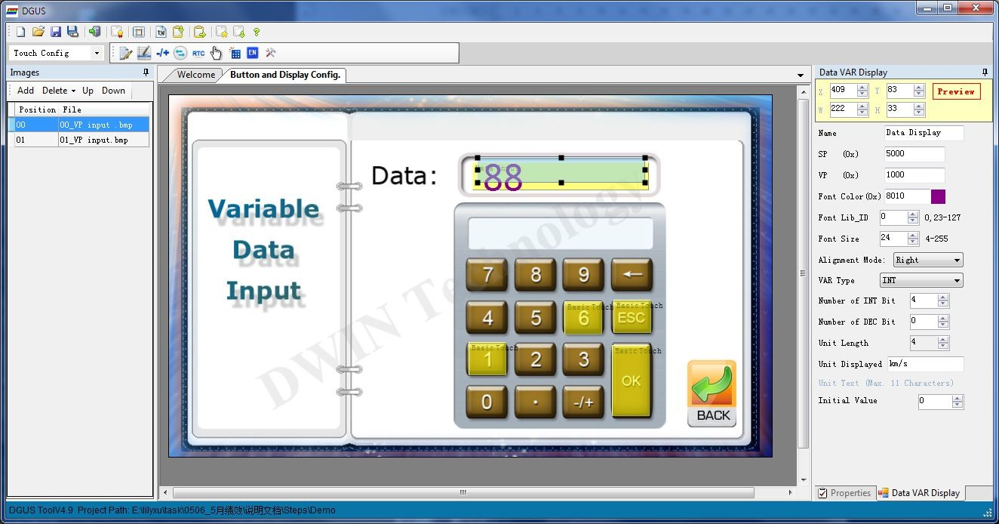

##### Professional, Creditable, Successful DGUS_SDK User Guide V5.1

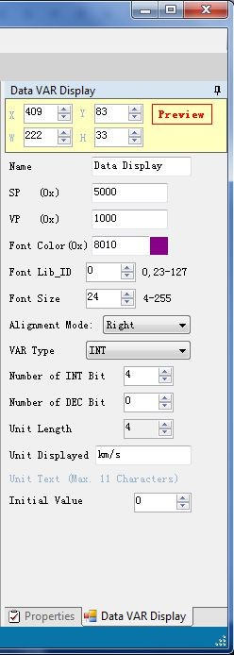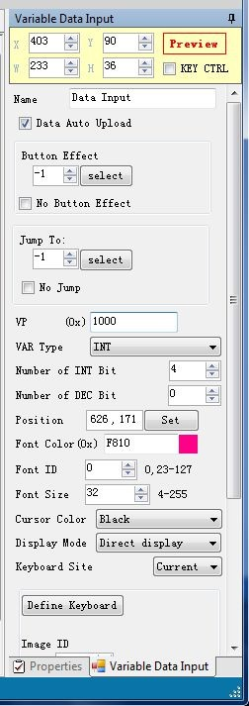

Supposing that reading & writing to the same one, touch and input parameters of VP should be the same accordingly.

## SP (Stack Pointer)

* + - 1. **About SP**

SP is the initial address for saving variable attributes which described features of the variables, such as font color, font size and unit of variables, etc. The variable attributes refers to the Chapter Five of DGUS Dev. Guide.

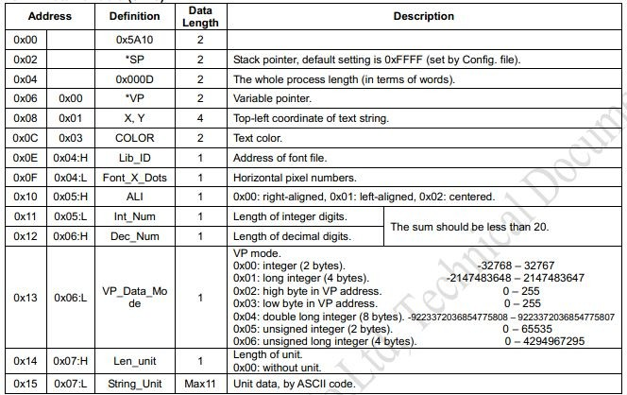

SP shares the same SRAM with VP from 0x0000 to 0x6FFF. It is only used for variable display but overlap exception.

Professional, Creditable, Successful DGUS_SDK User Guide V5.1

# How to use SP？

### Set SP via DGUS_SDK

Take “Data Display” as example:

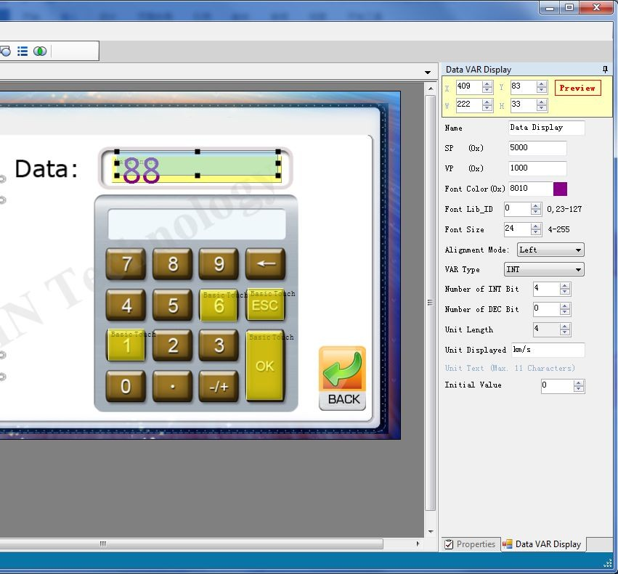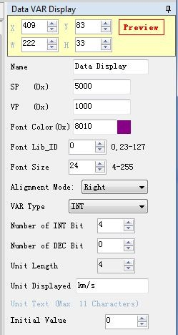

***SP 0x5000***

***VP***

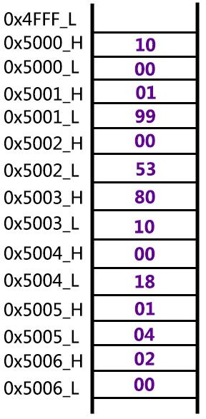

***X, Y***

***Color***

***Lib_ID***

***Font_X_Dots Aligment Mode***

。

。

。

Professional, Creditable, Successful DGUS_SDK User Guide V5.1

### Change variable attributes via SP

Same sample as above：

In operation, if user attempts to do the changes on data color to red, just need able to write down a new value into corresponding address.

***SP=0x5000***

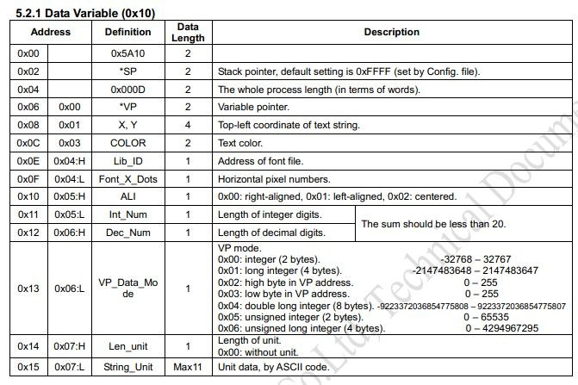

***The color is saved in 0x5003***

Frame header (2 Bytes)+Data length (1 Byte)+Command (1 Byte)+Data (N Byte: ADR+data/LEN)+CRC (2 Bytes, optional) Send:5A A5 05 82 50 03 F8 00

Description: 5003: the address of color F800: the value of red color

## Examples

Configure frame header and baud rate in CONFIG.TXT via DGUS SDK as below:

R1=07 R3=5A RA=A5

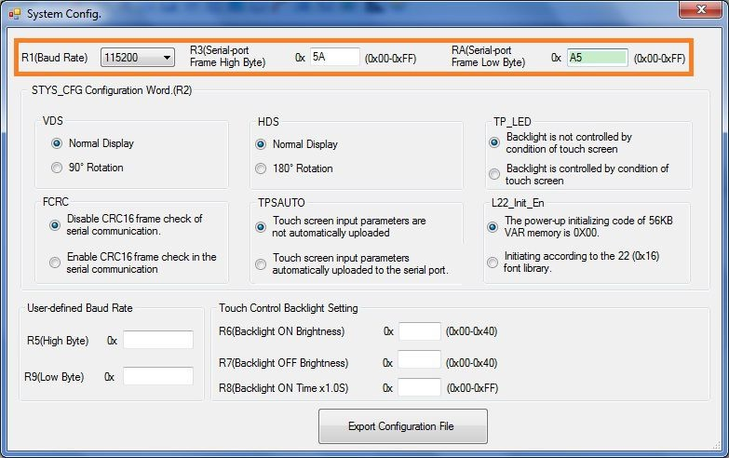

Frame header (2 Bytes)+Data length (1 Byte)+Command (1 Byte)+Data (N Byte: ADR+data/LEN)+CRC (2 Bytes)

Professional, Creditable, Successful DGUS_SDK User Guide V5.1

## Access Register of DGUS

## Write Data into Register

Switch current picture to pic_3:

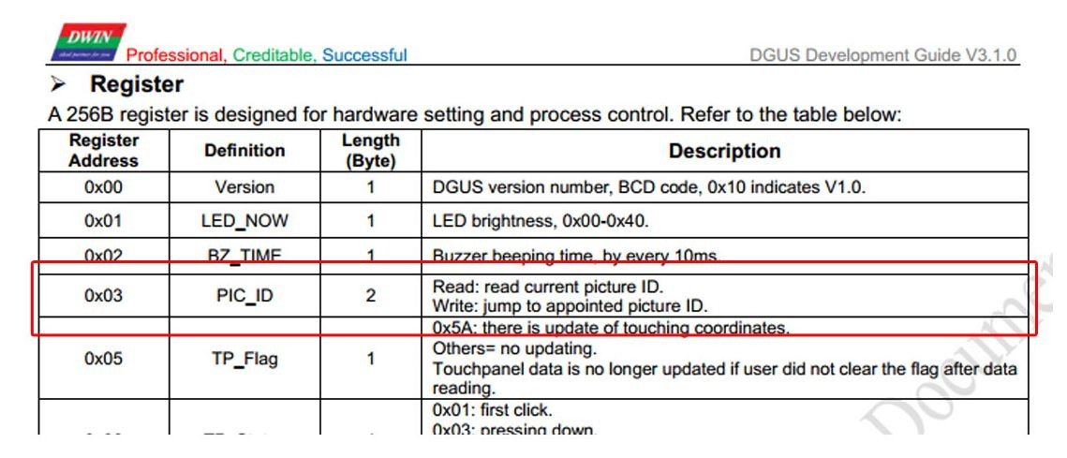

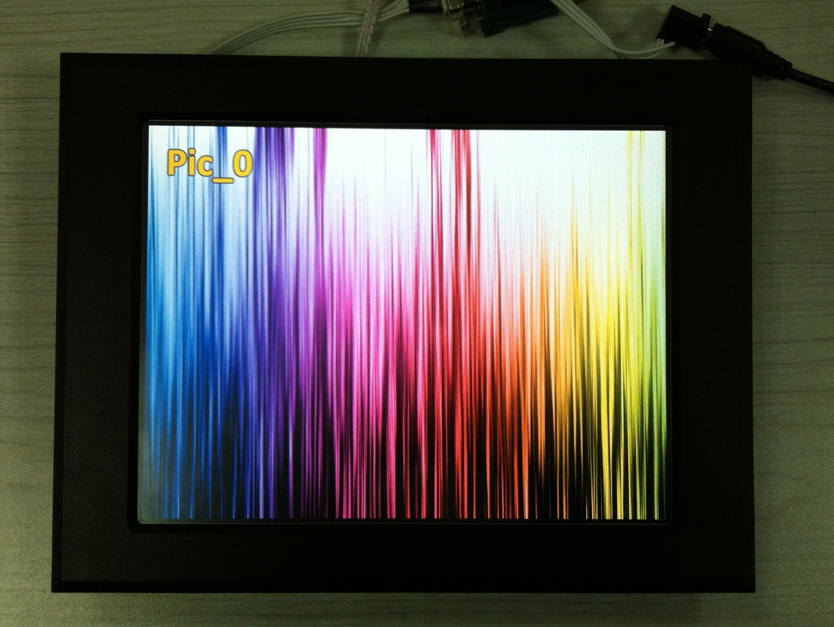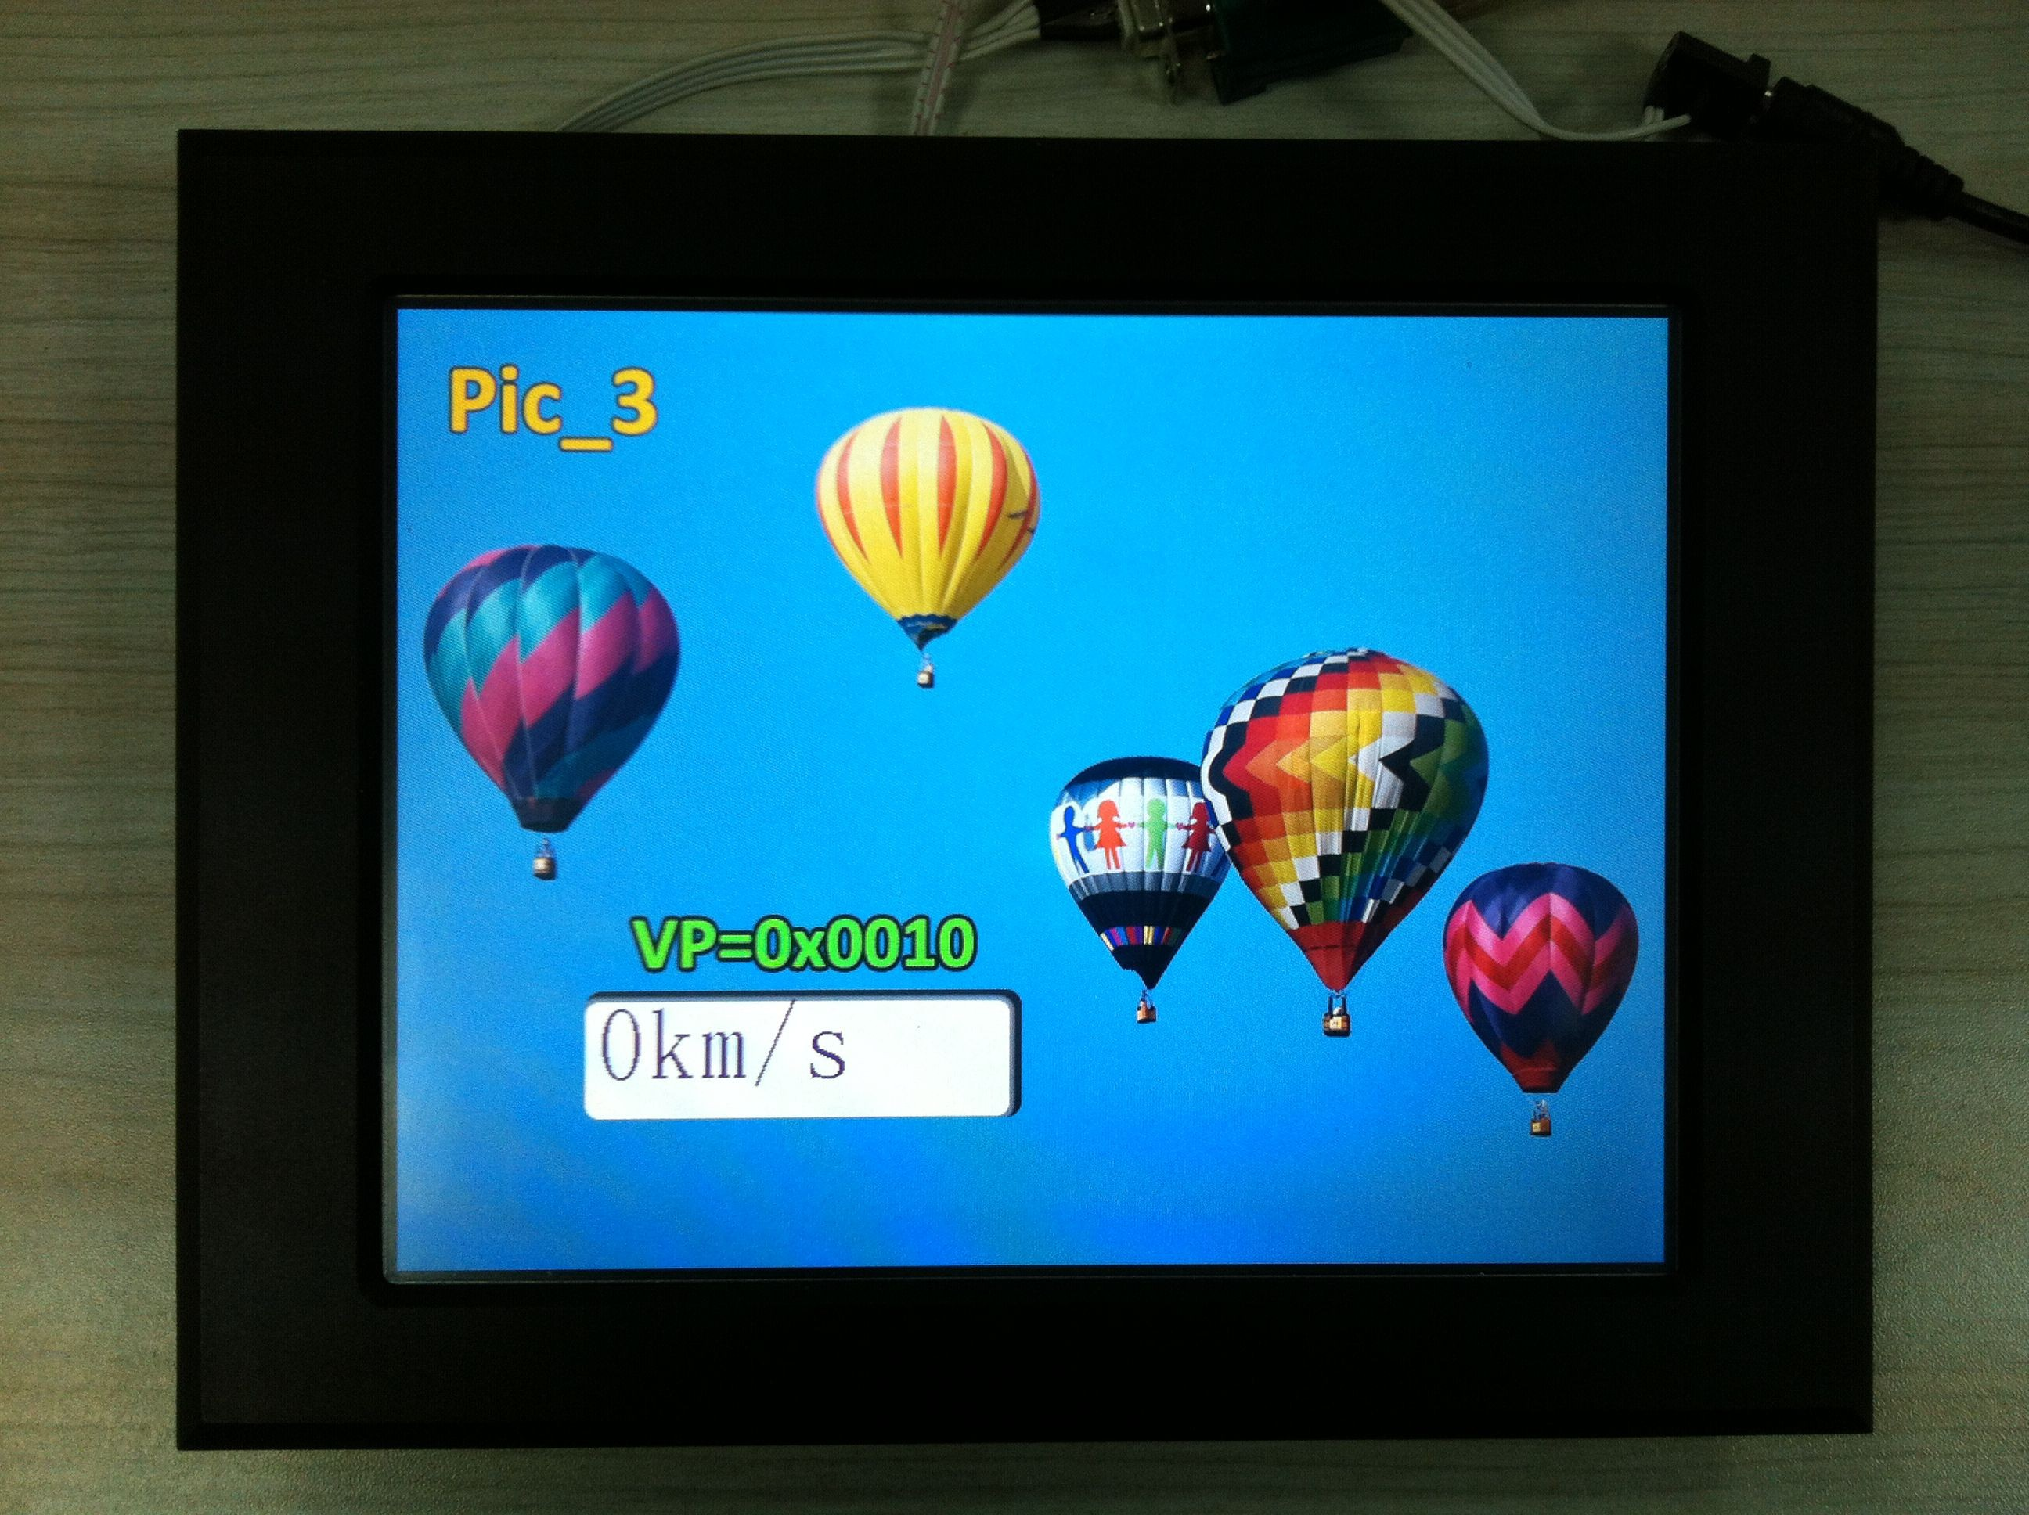

***Send:***  5A A5 04 80 03 00 03

***Description:*** 03: Register for Picture ID

00 03: Appoint picture ID

* + - 1. **Read Data from Register Handshaking**：Read DGUS version (V 5.7):

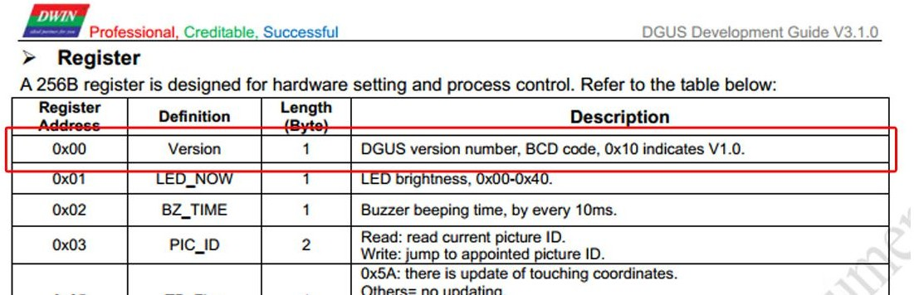

***Send:*** 5A A5 03 81 00 01

***Description:*** 00: Register for DGUS Version 01: Read data by a byte

## Response from the DGUS module

***Receive:*** 5A A5 04 81 00 01 47

***Description:*** 47: The version is 47 (V 4.7)

Professional, Creditable, Successful DGUS_SDK User Guide V5.1

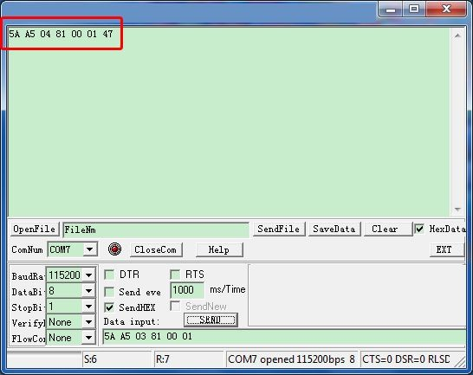

## Access Variable SRAM

## Write Data into variable SRAM

Write Data 100 to VP=0x0010

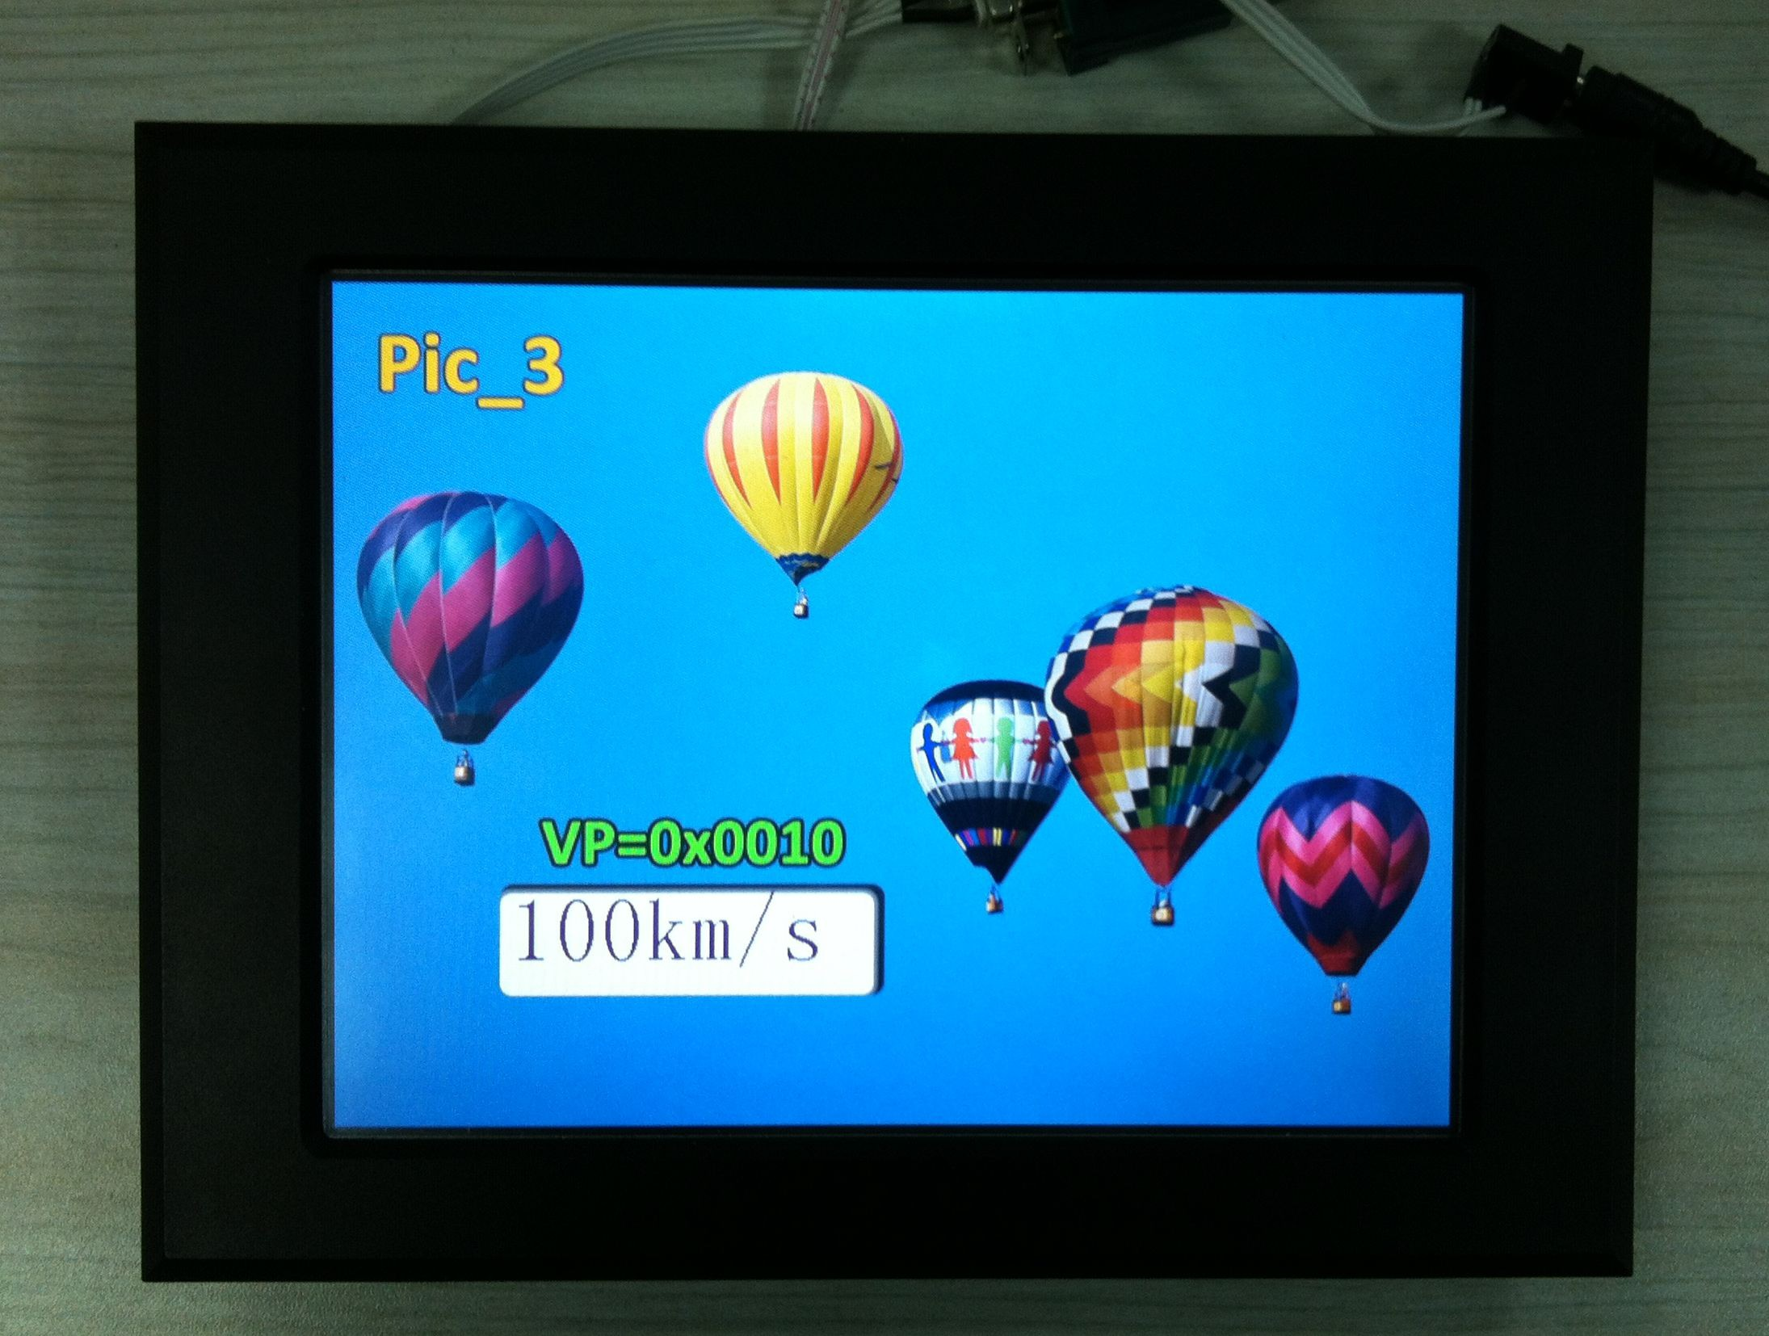

***Send:*** 5A A5 05 82 00 10 00 64

***Description:*** 0010: Variable pointer 0064:Data 100 in hexadecimal format



## Read Data from variable SRAM

04

83

***Send:*** 5A A5

00 10 01

***Description:*** 0010: Variable pointer 01: Read data by a word

## Response from the DGUS module

05

***Receive:*** 5A A5

83 00 10 01 00 20

***Description:*** 0020: Data 32 in hexadecimal format

## Dynamic Trend Curve Display

12

***Send:*** 5A A5

84 12 00 32 00 72 00 9F 00 04 00 17 00 36 00 93 00 1A

***Description:*** 12: Channel 4 & Channel 1, 8bit(0001 0010)

##### Professional, Creditable, Successful DGUS_SDK User Guide V5.1

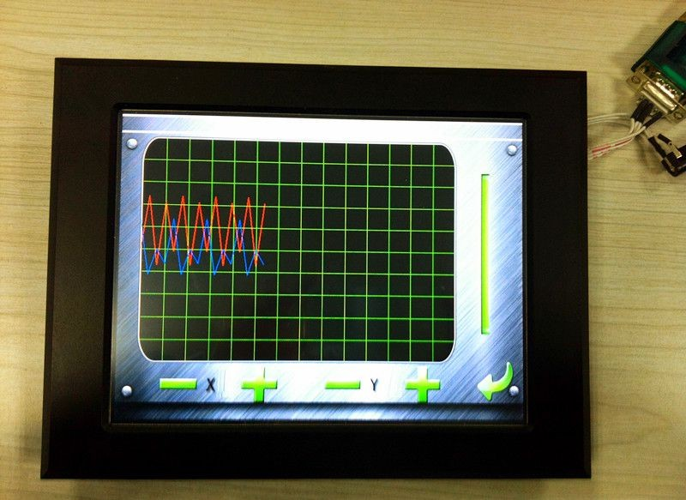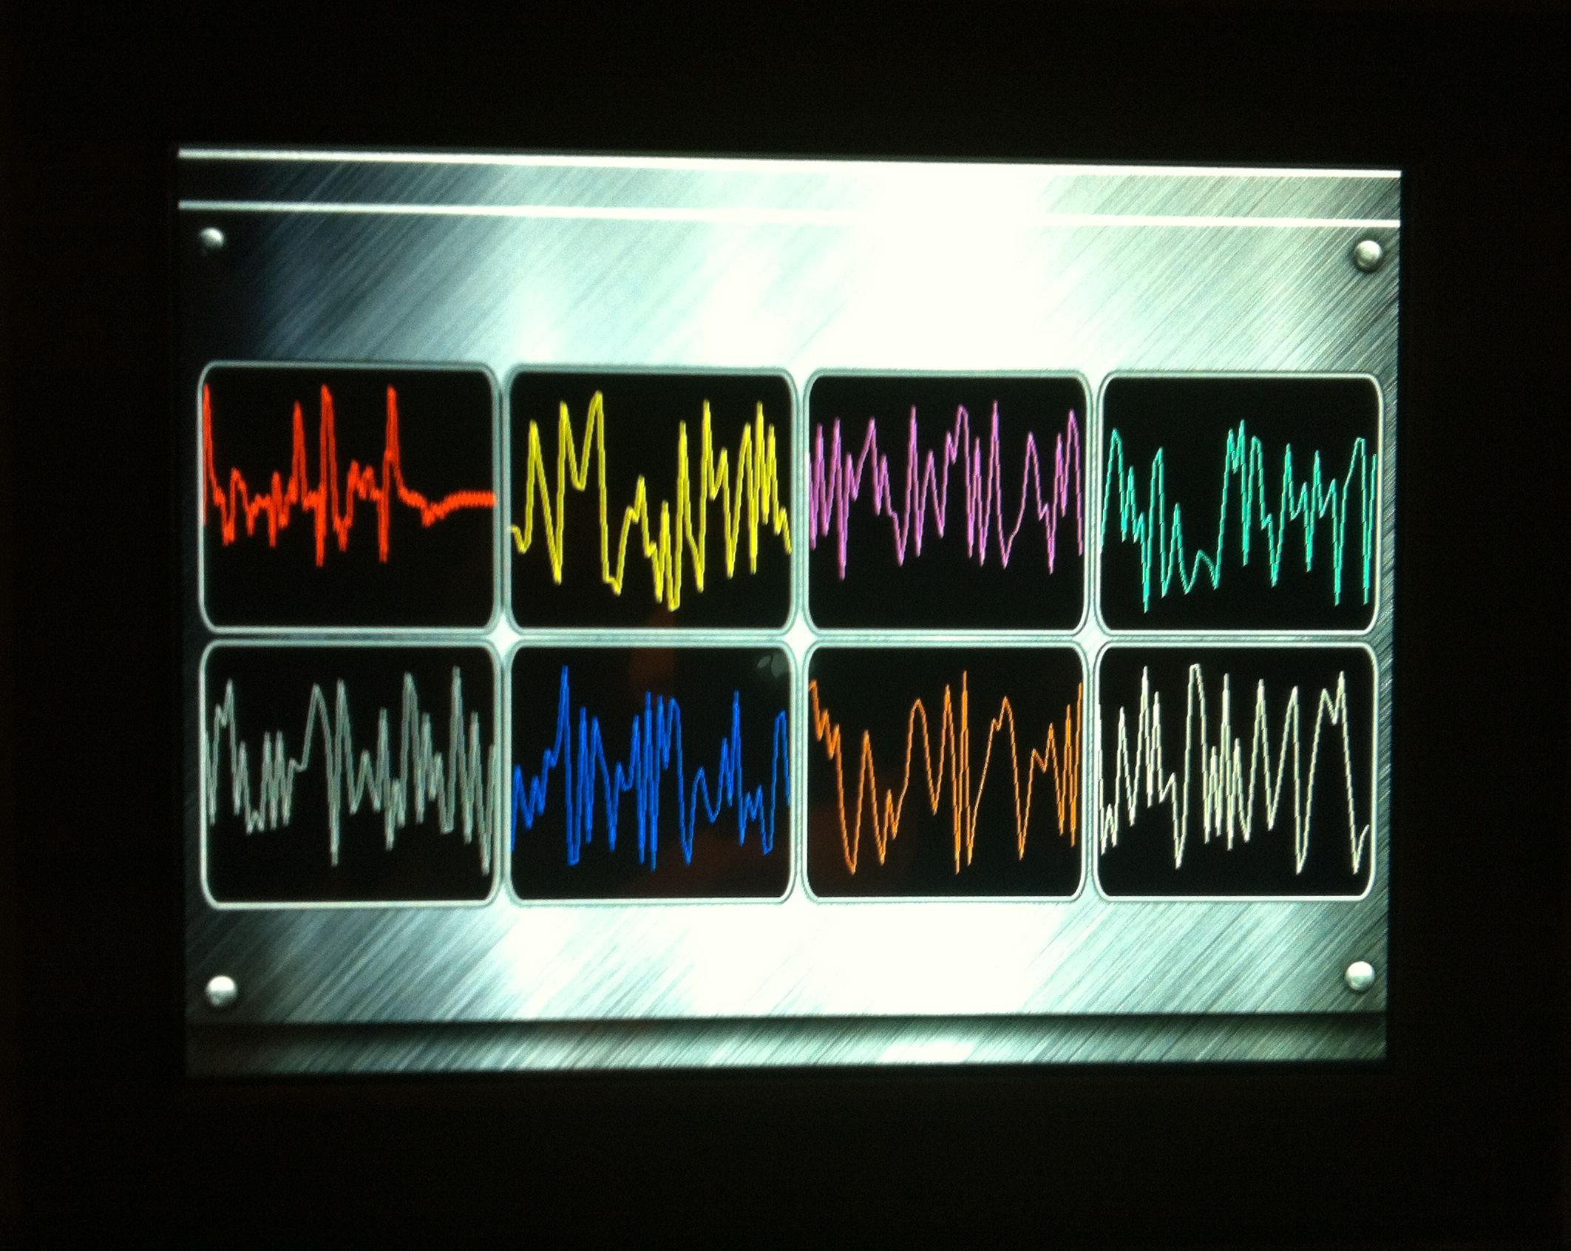

Display the trend curve in the same area Display the trend curve in the different area simultaneously

## Basic Graphic Display

String Format

|  |  |  |
| --- | --- | --- |
| **Address** | **Definition** | **Description** |
| **VP** | CMD | Command. |
| **VP+1** | Data_Pack_Num_Max | Max number of data packs.  For command 0x0002, it’s number of graph. |
| **VP+2** | DATA_Pack |  |

Date Pack For Basic Graphic

|  |  |  |  |  |  |
| --- | --- | --- | --- | --- | --- |
| **CMD** | **Function** | **Description of Data Format, by word** | | | |
| **Relative**  **Address** | **Data**  **Length** | **Definition** | **Description** |
| 0x0001 | Dot | 0x00 | 2 | (x, y) | Coordinate of dot. |
| 0x02 | 1 | Color | Color of dot. |
| 0x0002 | Line | 0x00 | 1 | Color | Color of line. |
| 0x01 | 2 | (x, y)0 | Coordinate of vertex 0. |
| 0x03 | 2 | (x, y)1 | Coordinate of vertex 1. |
| 0x01+2*n | 2 | (x, y)n | Coordinate of vertex n. |
| 0x0003 | Rectangle | 0x00 | 2 | (x, y)s | Coordinate of top-left. |
| 0x02 | 2 | (x, y)e | Coordinate of bottom-right. |
| 0x04 | 1 | Color | Color of rectangle. |
| 0x0004 | Rectangle Area Fill | 0x00 | 2 | (x, y)s | Coordinate of top-left. |
| 0x02 | 2 | (x, y)e | Coordinate of bottom-right. |
| 0x04 | 1 | Color | Filled color. |
| 0x0005 | Circle | 0x00 | 2 | (x, y) | Coordinate of center of circle. |
| 0x02 | 1 | Rad | Radius of circle. |
| 0x03 | 1 | Color | Color of circle. |
| 0x0006 | Picture  Cut/Paste | 0x00 | 1 | Pic_ID | Image ID of cutting area. |
| 0x01 | 2 | (x, y)s | Coordinate of top-left of cutting area. |

Professional, Creditable, Successful DGUS_SDK User Guide V5.1

|  |  |  |  |  |  |  |  |
| --- | --- | --- | --- | --- | --- | --- | --- |
|  |  | 0x03 | 2 | | (x, y)e | | Coordinate of bottom-right of cutting area. |
| 0x05 | 2 | | (x, y) | | Paste position on current screen. |
| 0x**07 | Icon Display | 0x00 | 2 | | (x, y) | | Coordinate of top-left of icon. |
| 0x02 | 1 | | ICON_ID | | Icon ID in icon file, high byte of command specifies  address of icon file, display mode is transparent. |
| 0x0008 | Area Fill | 0x00 | 2 | | (x, y) | | Coordinate of sampling dot. |
| 0x02 | 1 | | Color | | Filled color. |
| 0x0009 | Vertical Line | 0x00 | 1 | | Color0 | | Connect (X0, Y0s), (X0, Y0e) with color0. |
| 0x01 | 1 | | X0 | |
| 0x02 | 1 | | Y0s | |
| 0x03 | 1 | | Y0e | |
| CMD | Function | Description of Data Format, by word | | | | | |
| Relative  Address | Data  Length | Definition | | Description | |
| 0x0001 | Dot | 0x00 | 2 | (x, y) | | Coordinate of dot. | |
| 0x02 | 1 | Color | | Color of dot. | |
| 0x0002 | Line | 0x00 | 1 | Color | | Color of line. | |
| 0x01 | 2 | (x, y)0 | | Coordinate of vertex 0. | |
| 0x03 | 2 | (x, y)1 | | Coordinate of vertex 1. | |
| 0x01+2*n | 2 | (x, y)n | | Coordinate of vertex n. | |
| 0x0003 | Rectangle | 0x00 | 2 | (x, y)s | | Coordinate of top-left. | |
| 0x02 | 2 | (x, y)e | | Coordinate of bottom-right. | |
| 0x04 | 1 | Color | | Color of rectangle. | |
| 0x0004 | Rectangle Area Fill | 0x00 | 2 | (x, y)s | | Coordinate of top-left. | |
| 0x02 | 2 | (x, y)e | | Coordinate of bottom-right. | |
| 0x04 | 1 | Color | | Filled color. | |
| 0x0005 | Circle | 0x00 | 2 | (x, y) | | Coordinate of center of circle. | |
| 0x02 | 1 | Rad | | Radius of circle. | |
| 0x03 | 1 | Color | | Color of circle. | |
| 0x0006 | Picture Cut/Paste | 0x00 | 1 | Pic_ID | | Image ID of cutting area. | |
| 0x01 | 2 | (x, y)s | | Coordinate of top-left of cutting area. | |
| 0x03 | 2 | (x, y)e | | Coordinate of bottom-right of cutting area. | |
| 0x05 | 2 | (x, y) | | Paste position on current screen. | |
| 0x**07 | Icon Display | 0x00 | 2 | (x, y) | | Coordinate of top-left of icon. | |
| 0x02 | 1 | ICON_ID | | Icon ID in icon file, high byte of command specifies address  of icon file, display mode is transparent. | |
| 0x0008 | Area Fill | 0x00 | 2 | (x, y) | | Coordinate of sampling dot. | |
| 0x02 | 1 | Color | | Filled color. | |
| 0x0009 | Vertical Line | 0x00 | 1 | Color0 | | Connect (X0, Y0s), (X0, Y0e) with color0. | |
| 0x01 | 1 | X0 | |
| 0x02 | 1 | Y0s | |
| 0x03 | 1 | Y0e | |

## Status Flag:

0xFF Current drawing operation finished. 0xFE This operation will be skipped (ignored).

Professional, Creditable, Successful DGUS_SDK User Guide V5.1

#### Take Circle Drawing for example

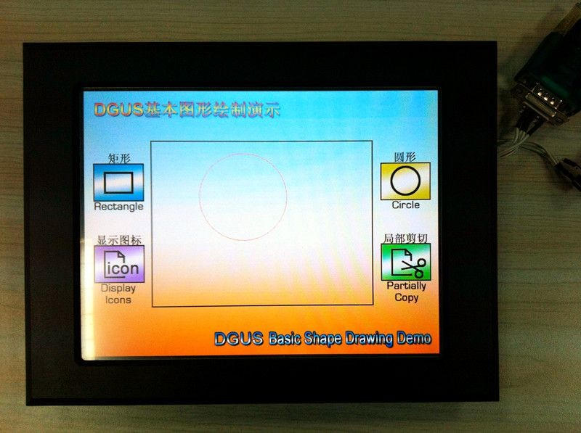

1. Add a basic graphic display via DGUS SDK software and set vp to 0x00A0 as below:

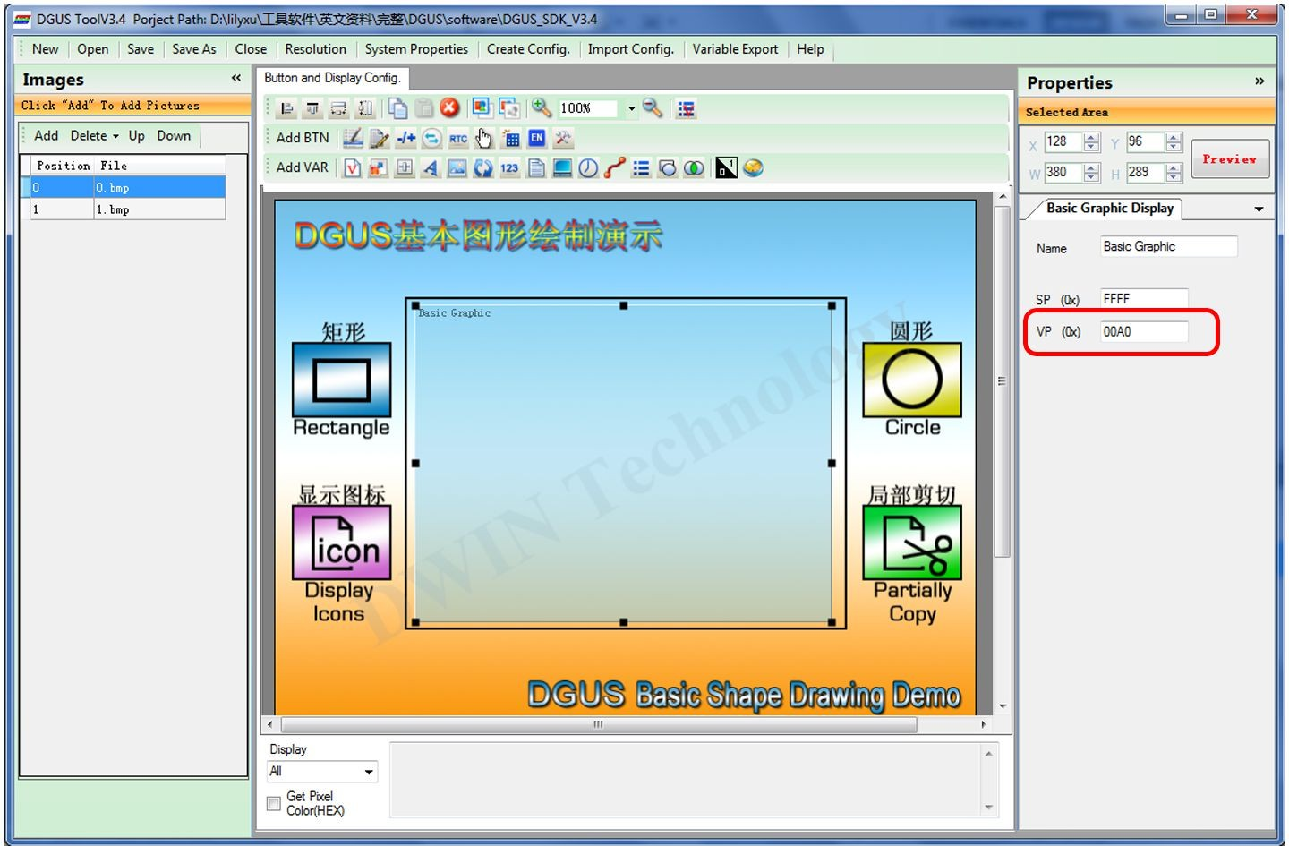

1. Send commands by serial port

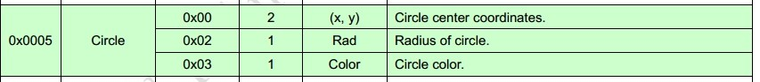

***Send:*** 5A A5 11 82 00 A0 00 05 00 01 01 64 00 EF 00 64 F8 00 FF 00

Professional, Creditable, Successful DGUS_SDK User Guide V5.1

|  |  |
| --- | --- |
| **Hex** | **Description** |
| 5A A5 | Frame header |
| 11 | Data length |
| 82 | Command |
| 00 A0 | VP |
| 00 05 | Circle command |
| 00 01 | One circle |
| 01 64 | X coordinate of center of circle:356 |
| 00 EF | Y coordinate of center of circle:239 |
| 00 64 | Radius of circle:100 |
| F8 00 | Color: red |
| FF 00 | Drawing operation finished |